Template document status – do not change
Version | 1.0
Date | 06/2025
Status | Released
Classification | Restricted
Template document responsible

Important notes:
Test responsible:
In the IT Requirement (ITR) process the user acceptance test is responsible for the Requester/Key User. For the internal integration test as part of a bug fix (Change request) the test is in responsibility of the Application Analyst.
Test result:
The test result must be recognizable.
Screenshots:
All screenshots must have an IPE-compliant display which means that date, time and the SAP System/Client must be included in every screenshot.
Naming Convention:
Name of the test document should start with SX_ followed by the ticket number of the change document. Optionally the document type UAT (FTC) can be added, e.g. S_UAT_4100002725_testdocument. – to be revised with the completion of the SHERPA X transition
Reference ticket number:
For internal integration test please use the number of the change document (e.g. normal change) as the reference ticket. The user acceptance test should refer to the respective IT Requirement.

Test document history
Title / Filename |  |  | <File Name>
Date | Version | Short description |  | Created by
30.06.2025 | 1 | SX-131990 - SX_XBT_DEV_GFCLD_DIR_SX-BTP PO Change Event Handling for Direct X (MPV) |  | Poornima M R
DD/MM/YYYY | Version | Description |  | Name

Testing details:
Date of test | 30.06.2025
Name and department of tester | Poornima M R
System | ☐ DEV | ☒ QA | ☐ PROD
Reference ticket number
Testcase – Checking of Bug Fix related to Ticket No: 8500014360
Retriggering of workflow when PO price is changed in the PO line item and has a user story: SX-131990 - SX_XBT_DEV_GFCLD_DIR_SX-BTP PO Change Event Handling for Direct X (MPV)
- PR Creator: Create the Purchase Requisition using Create Purchase Requisition (FIORI App Code: ME51N)
    - PR Doc. Type:
    - Acct. Assg: 4
    - Item Category:
    - Material: Blank
    - Mat.Group: WAA
    - Short Text: SRE Direct
    - Quantity: 1st line Item – 1
    - UOM: PC
    - Plant: C300
    - Purchasing Group: I14
    - Purchasing Organisation: C300
    - Fixed Vendor: Insert a valid Supplier
    - Valuation Price: 51000
    - Recipient: Authorized GID
    - G/L Account: PC30000008
    - Cost Center: C30000008
    - Requisitioner: Authorized GID

Screenshot – PO Creator: Create FW PR - 10332953
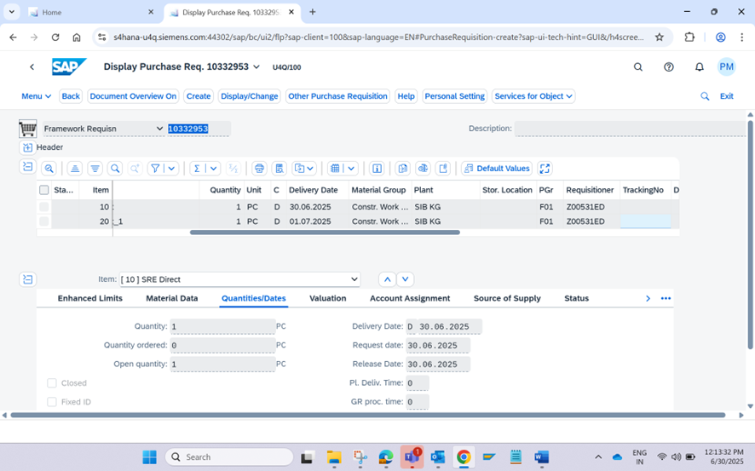

Screenshot: PR creator: Receive Email notification
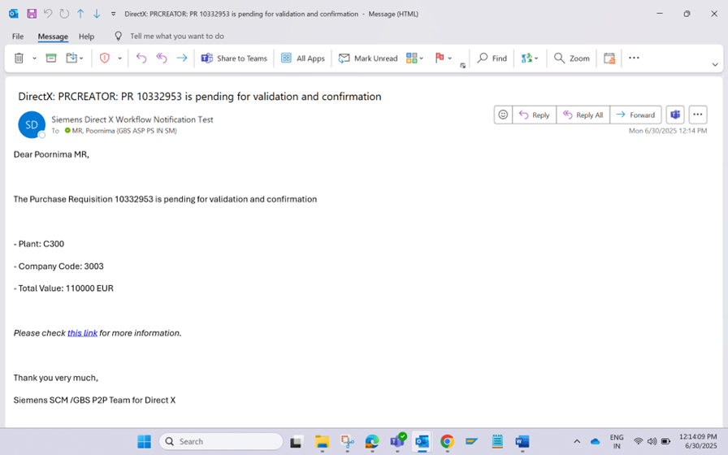

Screenshot: Requisitioner BTP notification
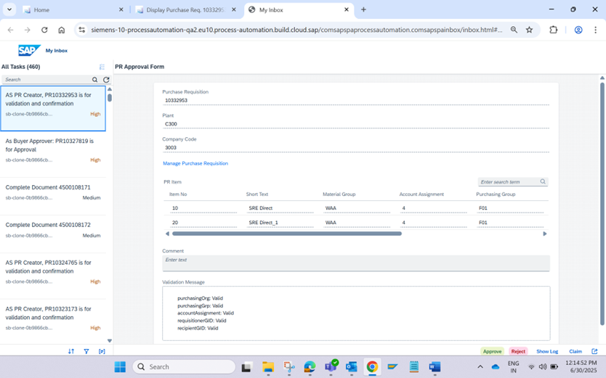

Screenshot: Buyer Receive Notification
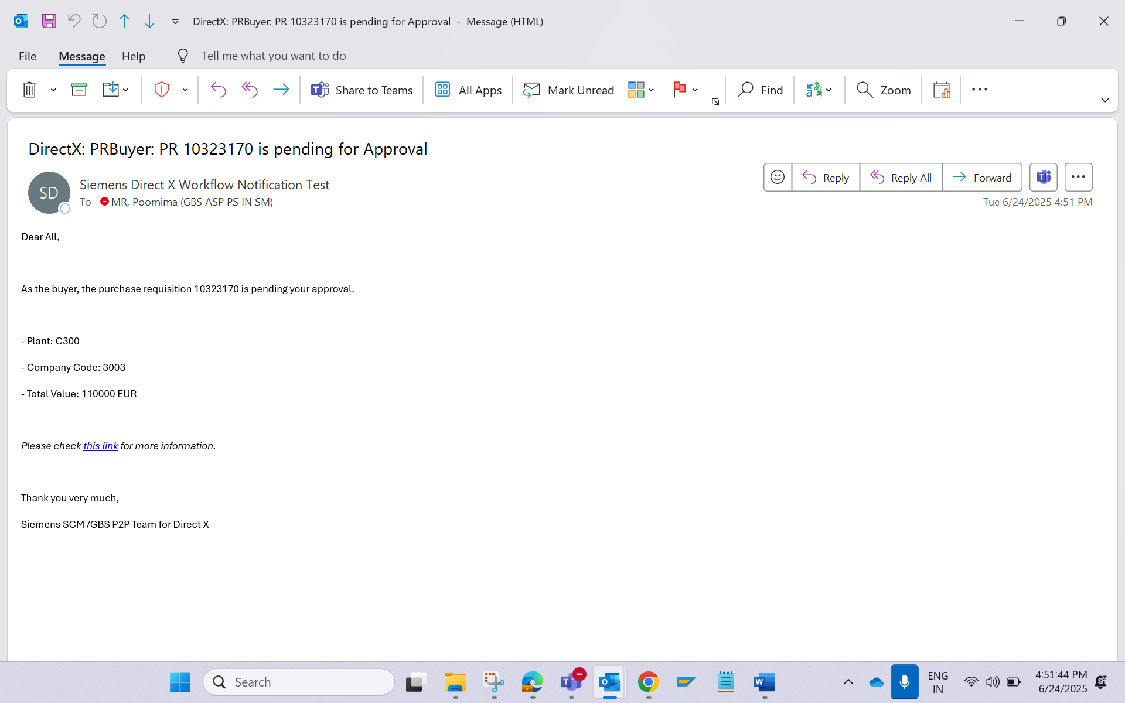
Screenshot: Buyer BTP notification (Change the Pgroup and approve the PR)
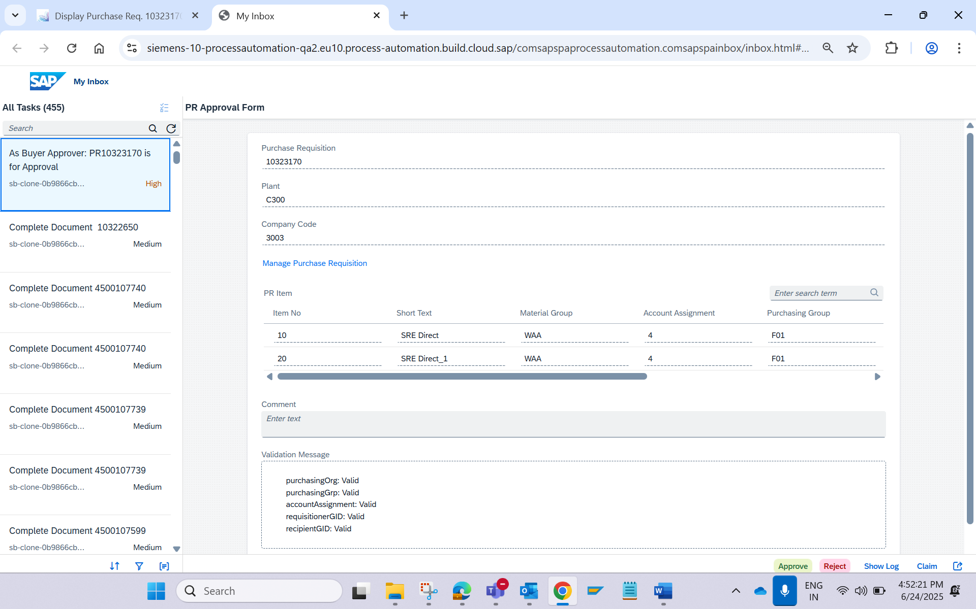

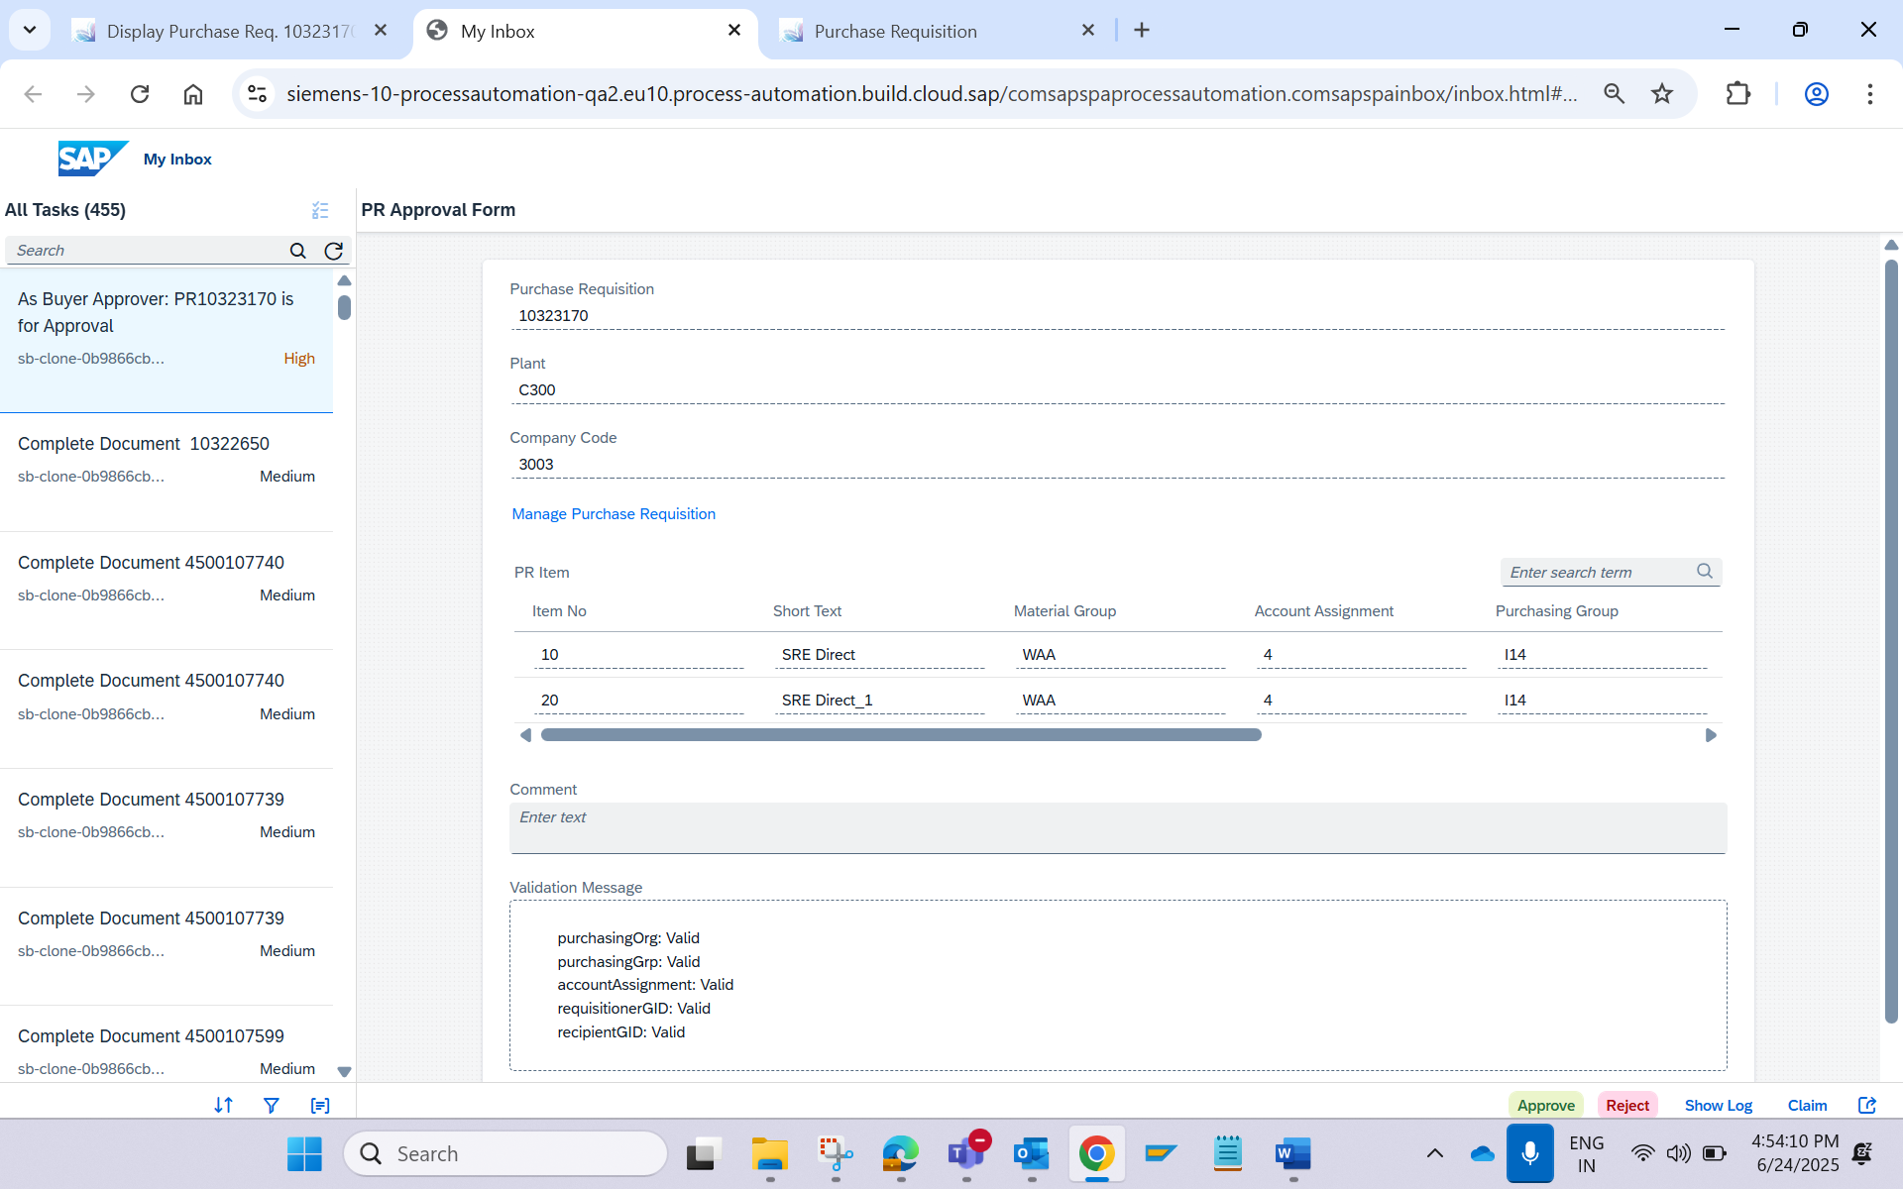

Screenshot: Purchaser receive the Email notification
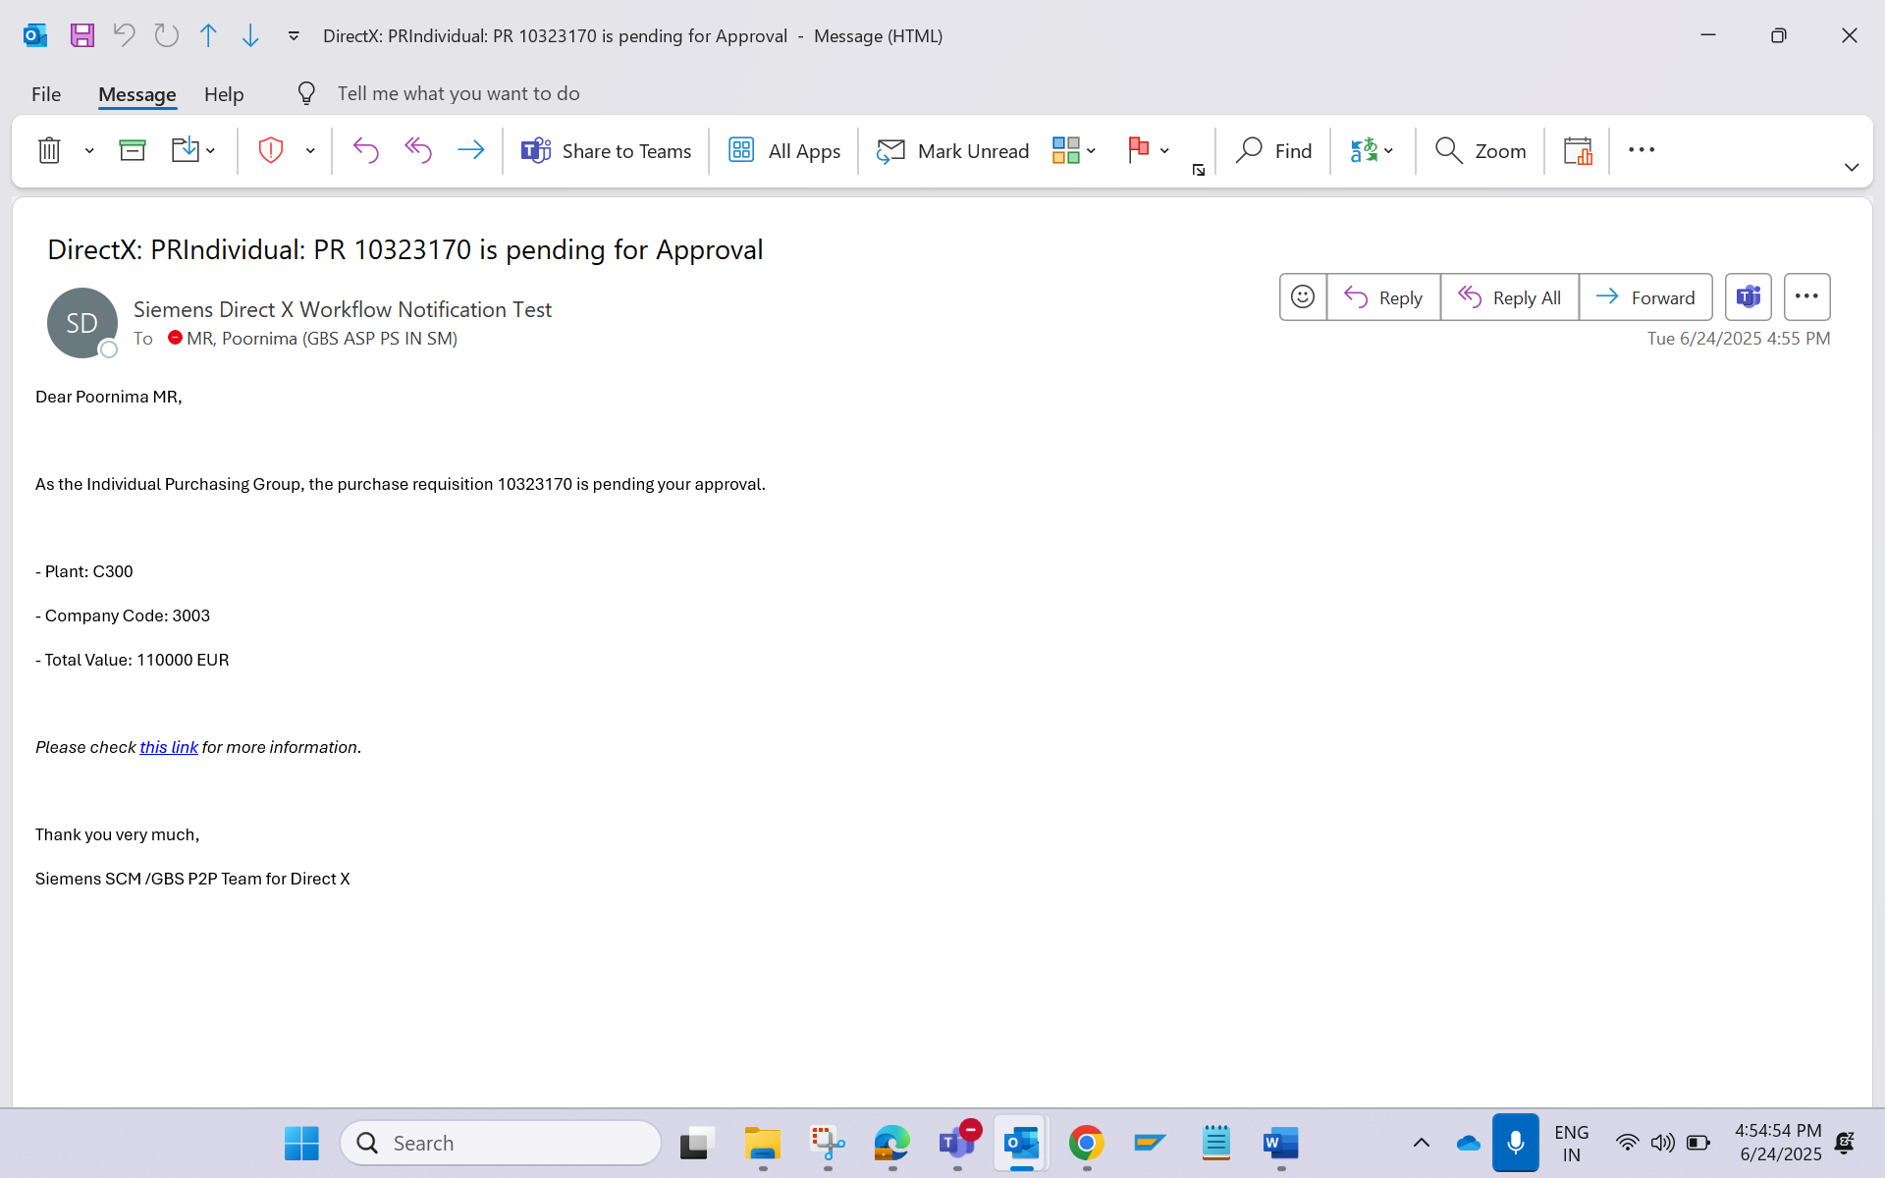

Screenshot: Purchaser Approve BTP form
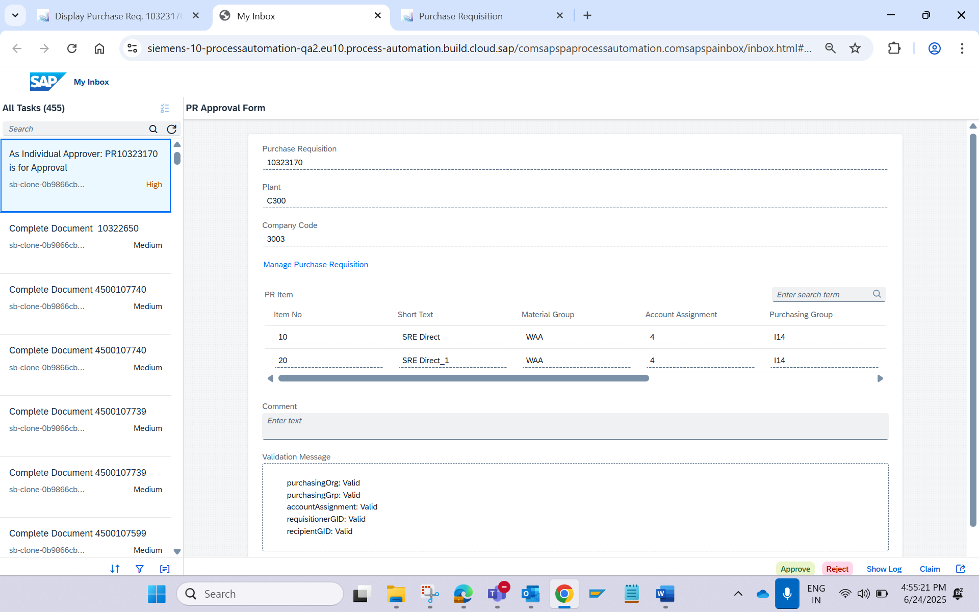

Screenshot: PR is released
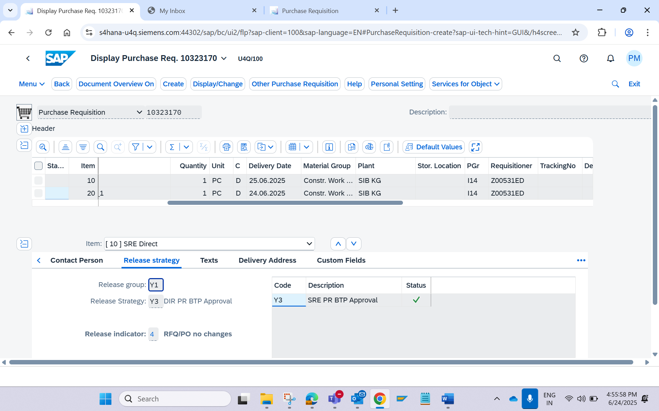

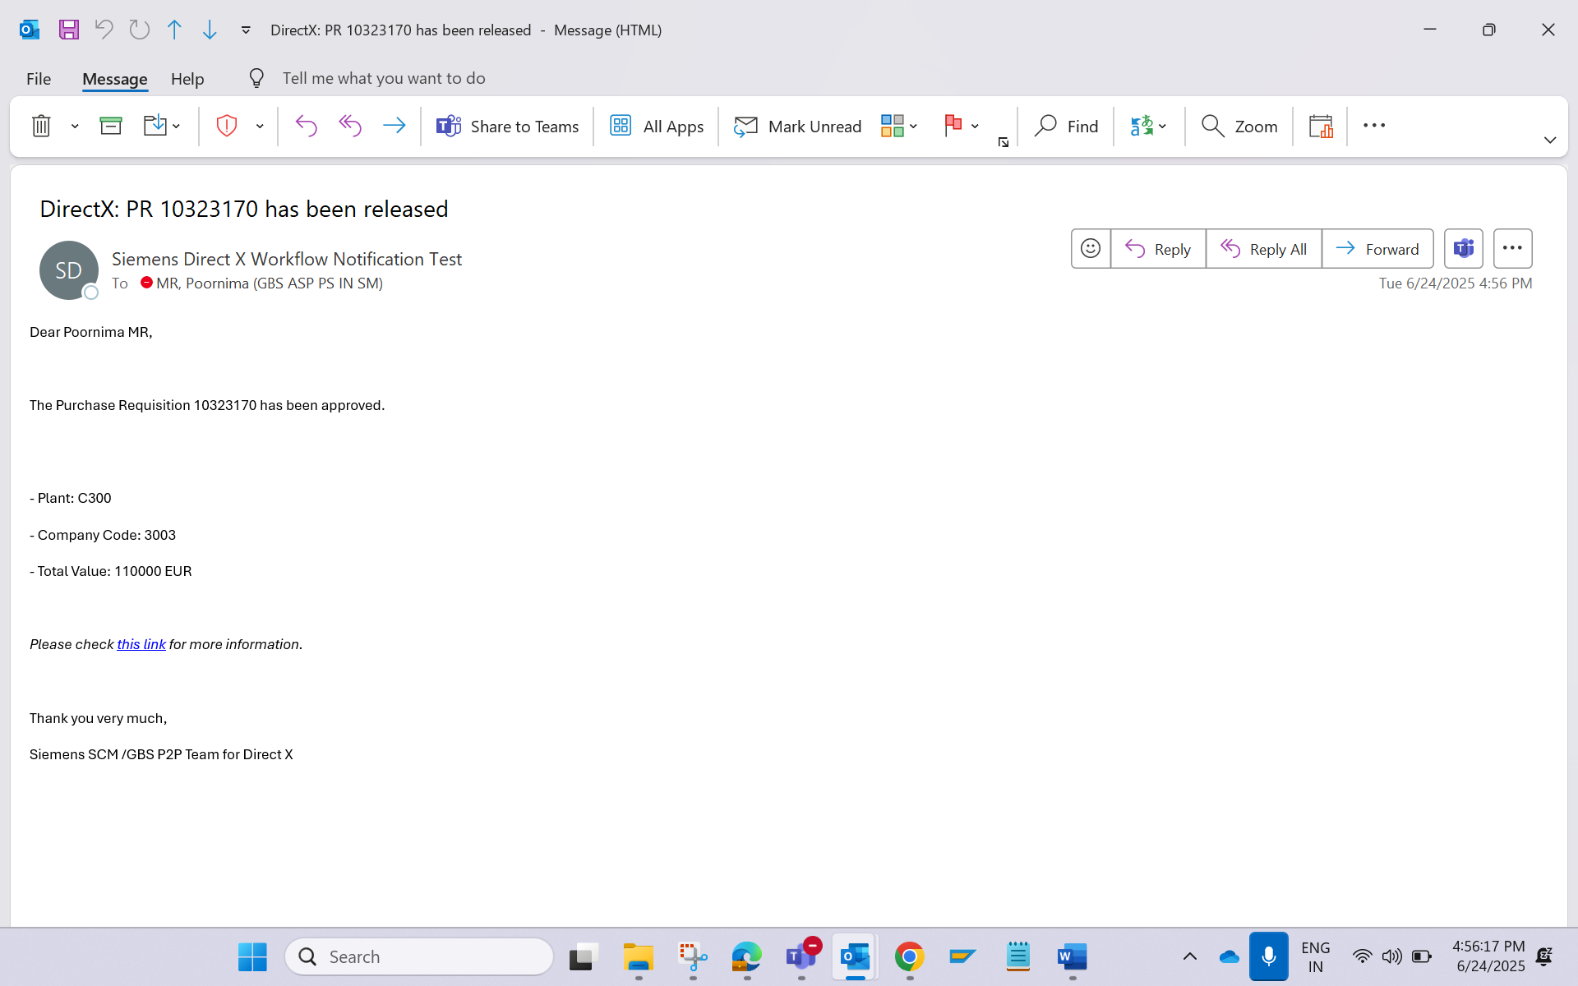
- PO Creator: Create the Purchase Order using Create Purchase Order (FIORI App Code: ME21N),
    - PR Doc. Type: YDNB
    - Acct. Assg: 4
    - Item Category:
    - Material: Blank
    - Mat.Group: WAA
    - Short Text: SRE Direct
    - Quantity: 1st line Item – 1
    - UOM: PC
    - Plant: C300
    - Purchasing Group: I12
    - Purchasing Organisation: C300
    - Fixed Vendor: Insert a valid Supplier
    - Valuation Price: 55000
    - Recipient: Authorized GID
    - G/L Account: PC30000008
    - Cost Center: C30000008
    - Requisitioner: Authorized GID

Screenshot: Creation of PO with first line item: - 4500108105
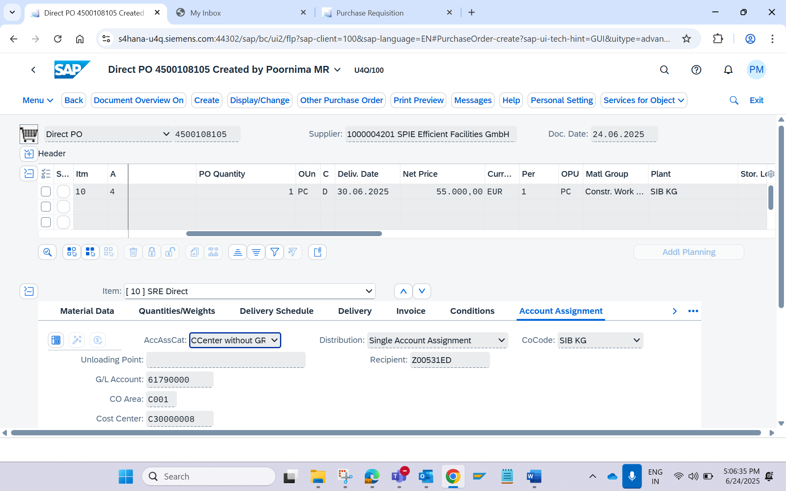

Screenshot: Receive Email Notification
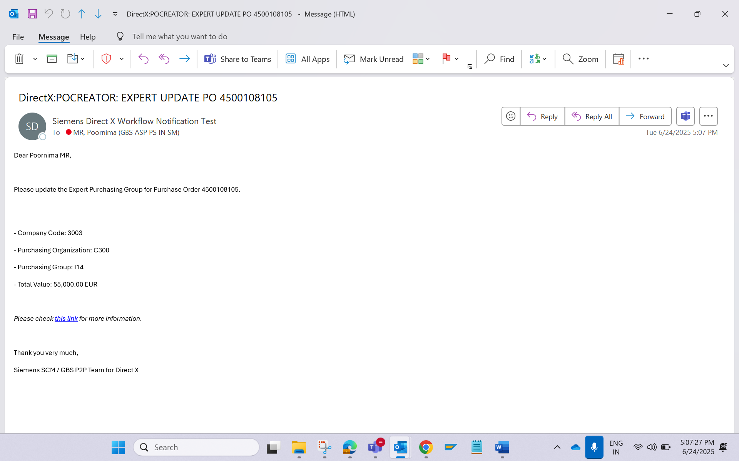

Screenshot: BTP form
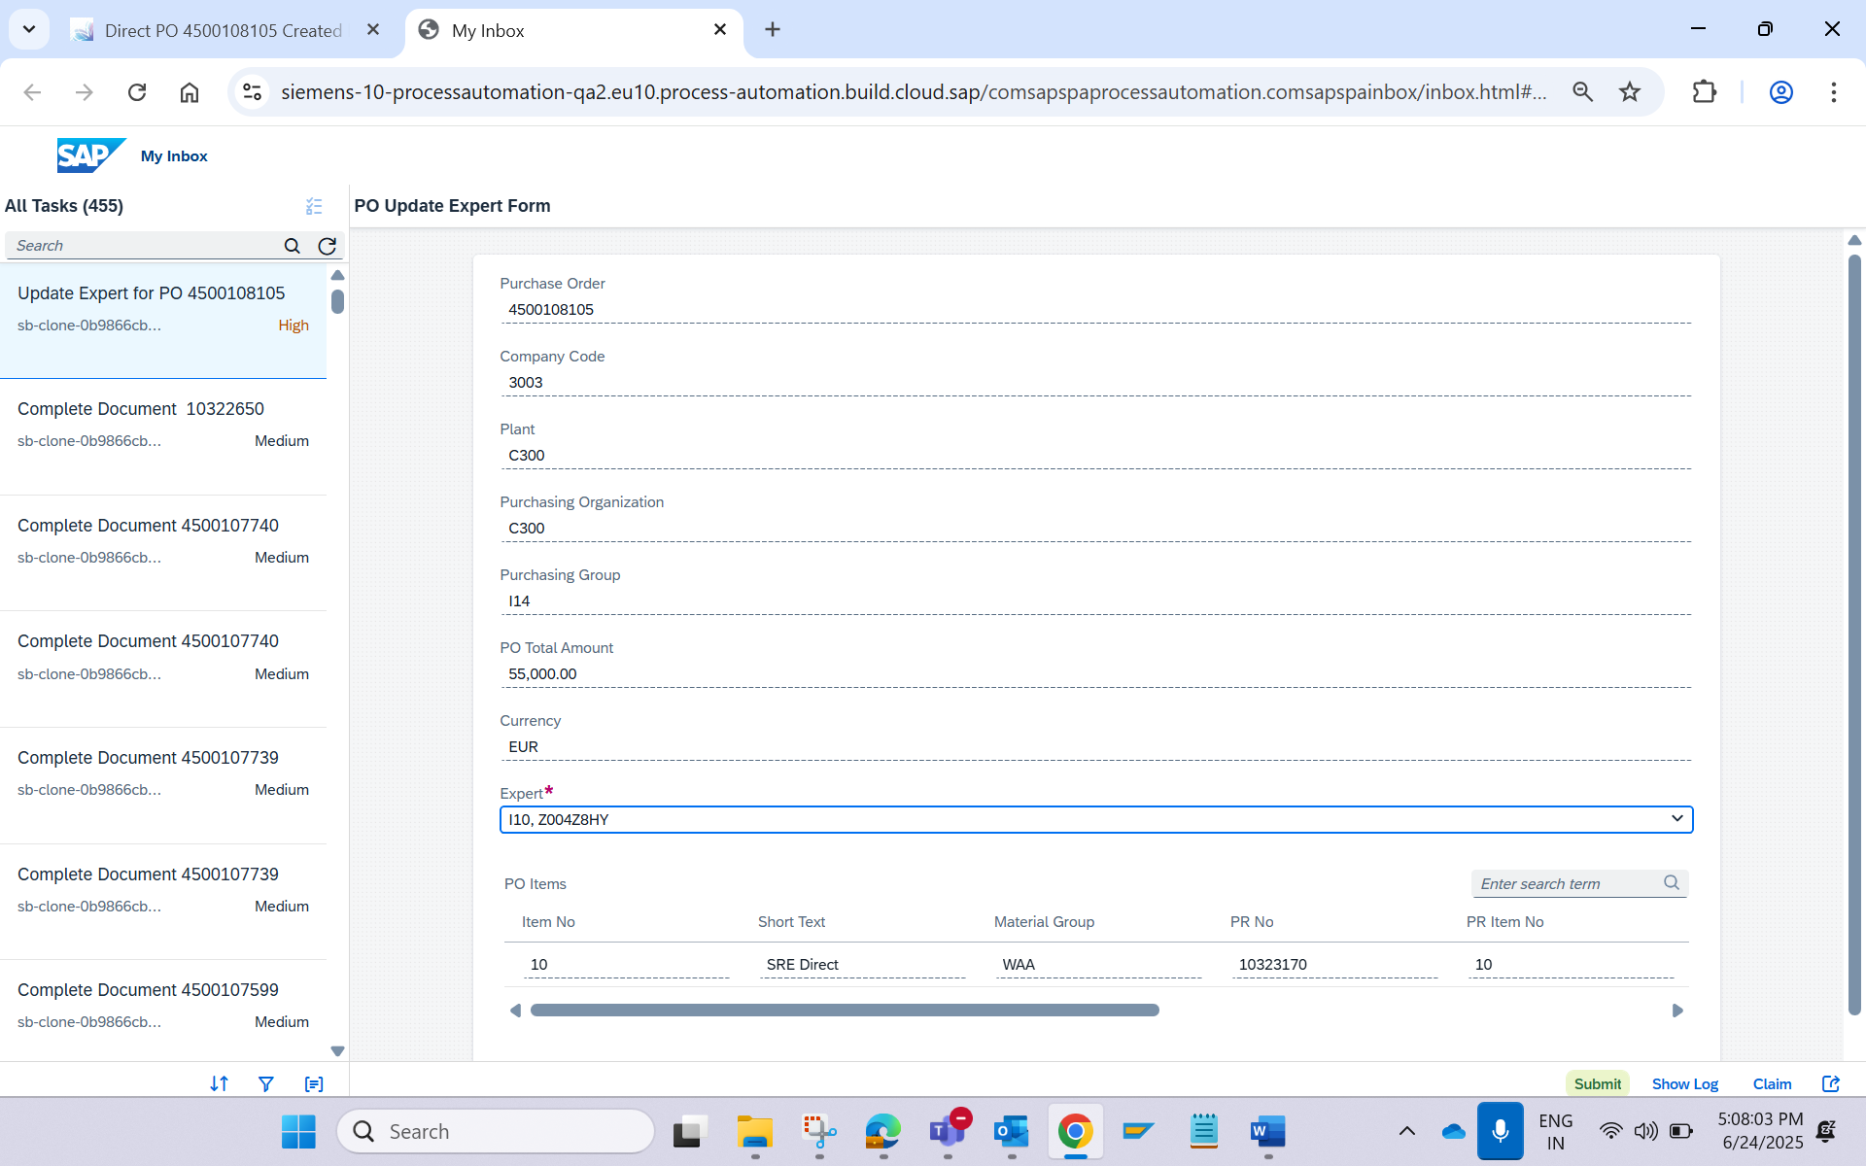

Update the expert and submit the form

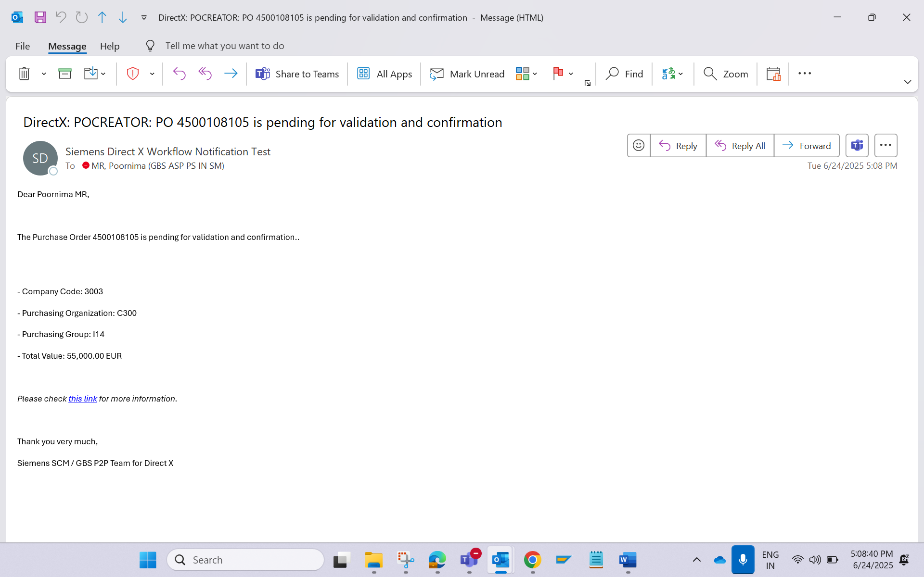

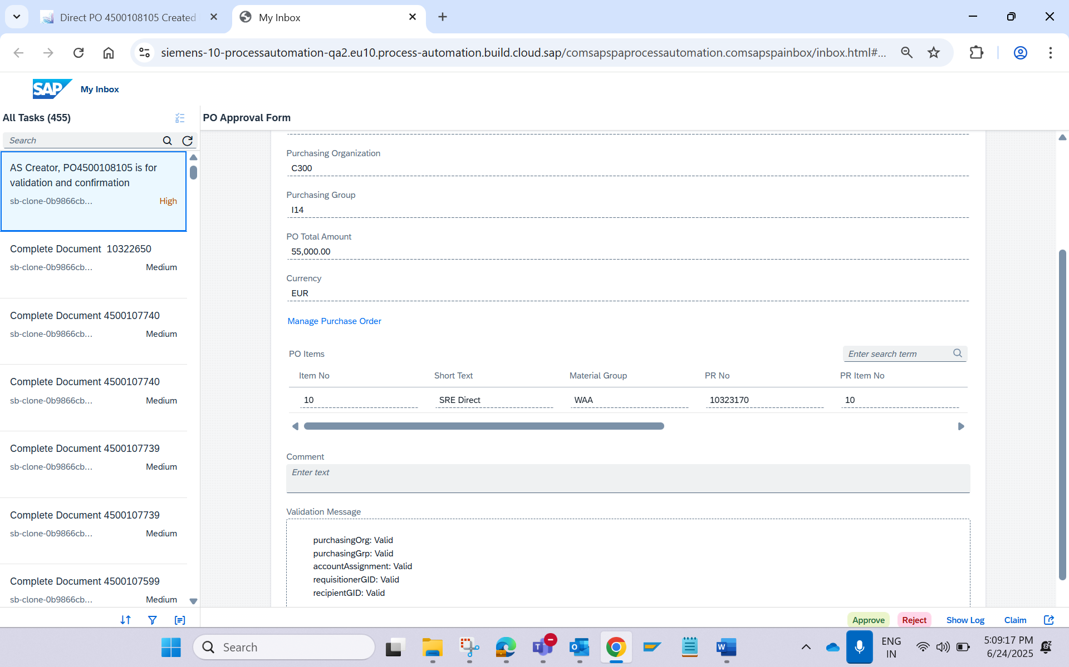

Screenshot: Expert Receive the Email Notification
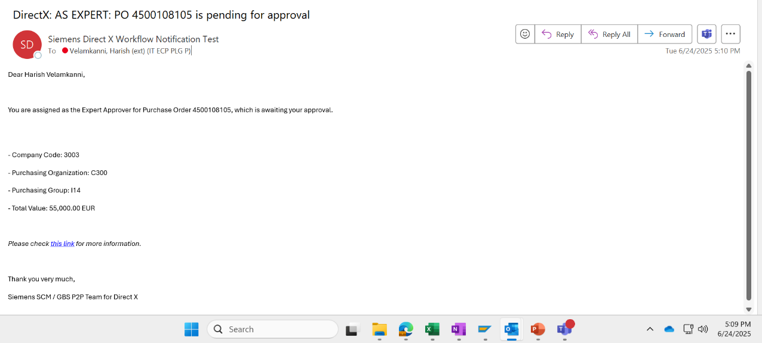

Screenshot: Receive BTP notification and approve the PO
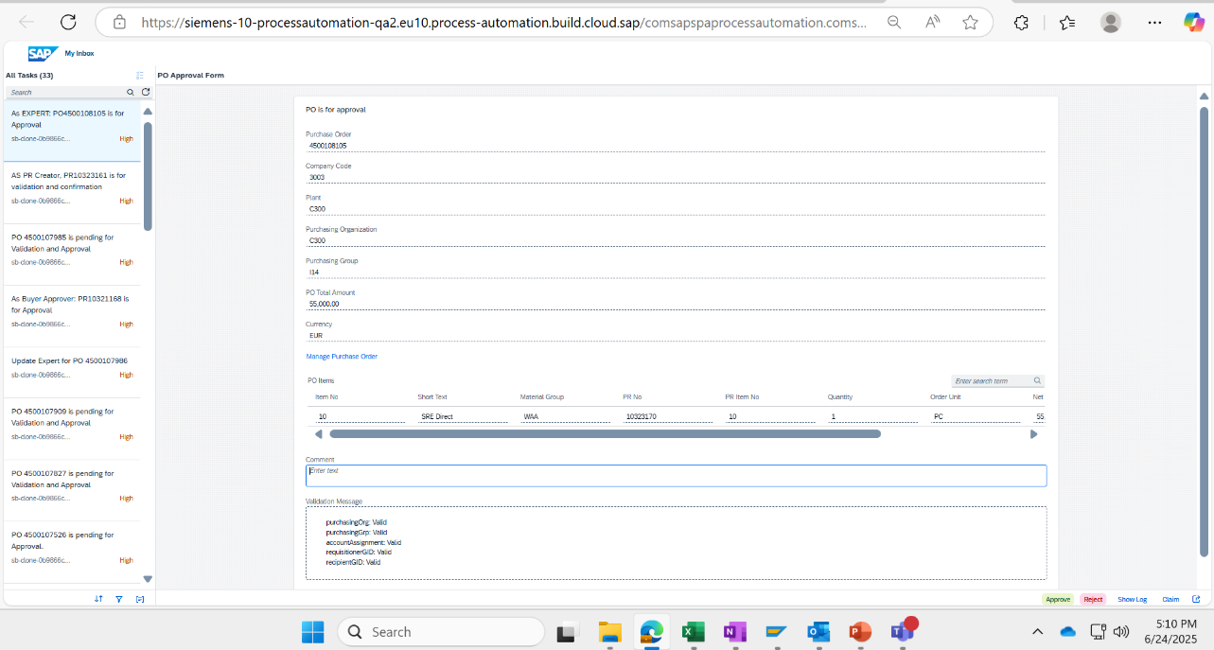

Screenshot: Functional Approver receive Email Notification
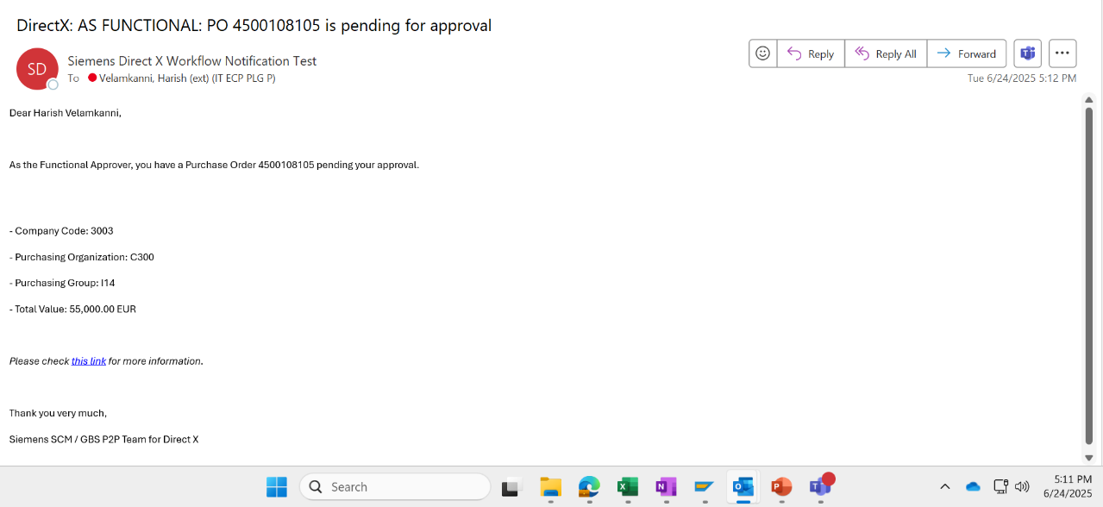

Screenshot: Functional Approver BTP approval
Screenshot: Commercial Approver receive Email Notification
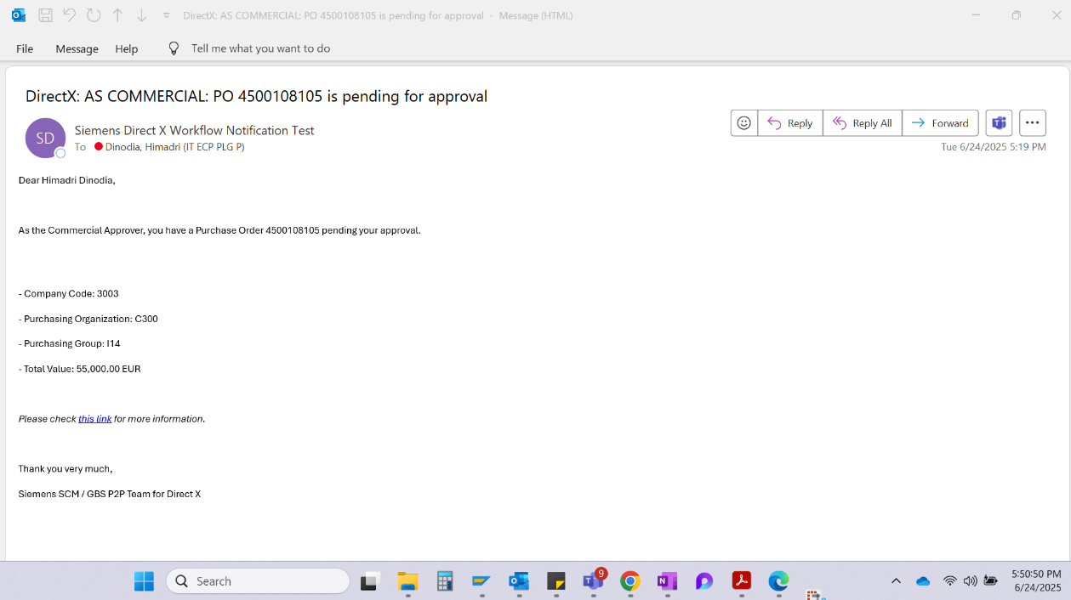

Screenshot: Commercial Approver receive BTP Notification
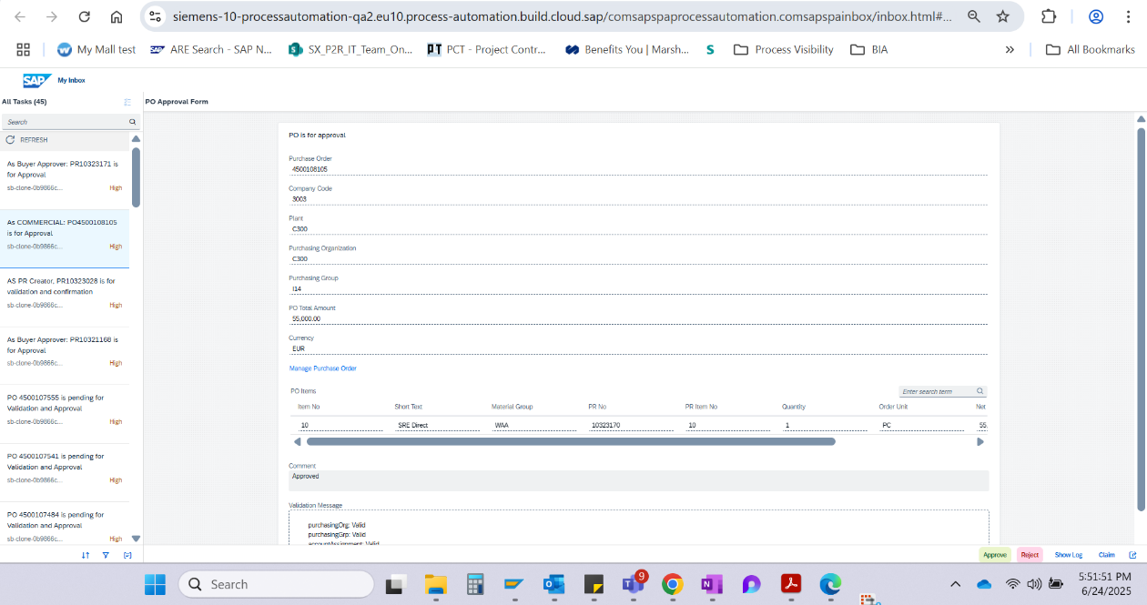

PO is Released
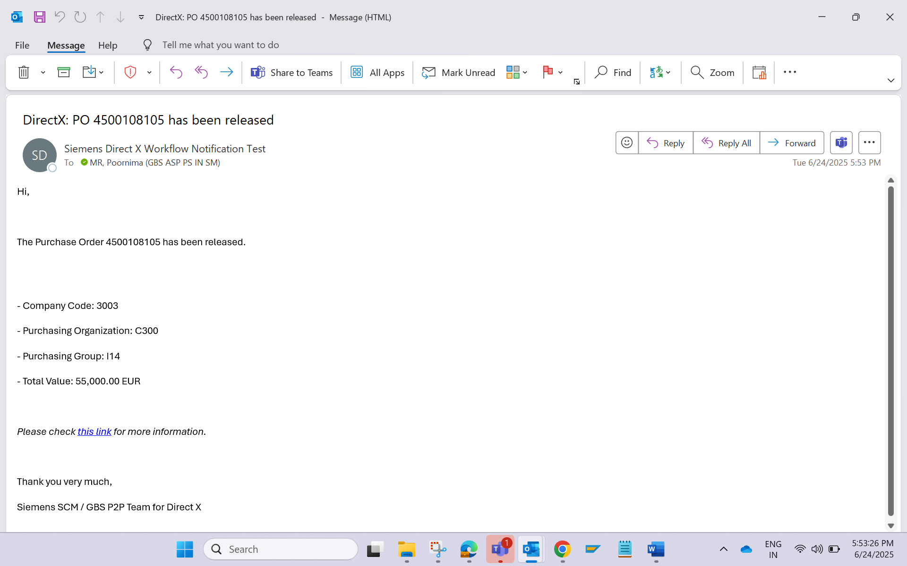

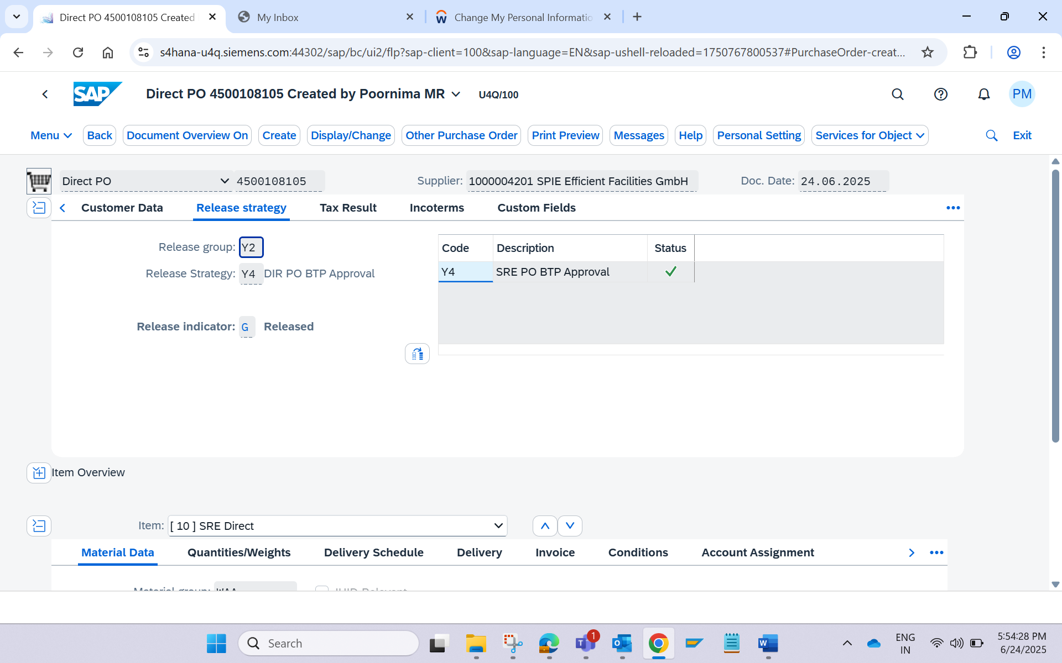

Adding second line item in the PO – and new workflow will retrigger
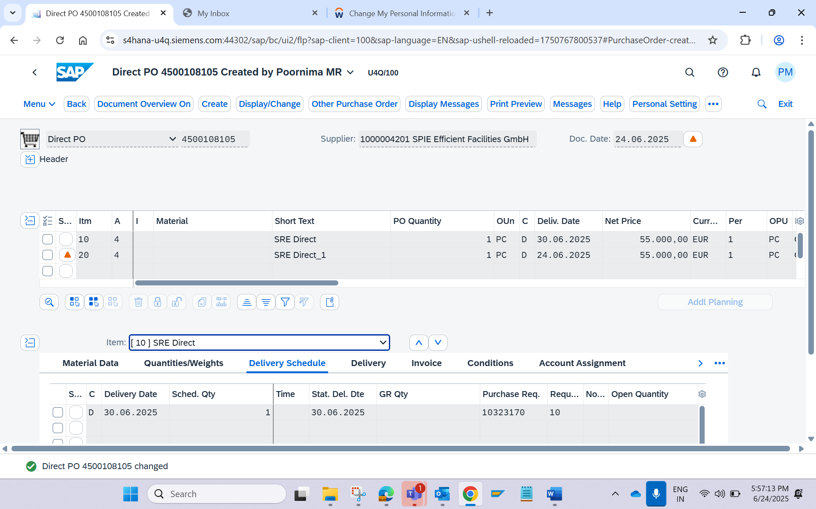

New Mail Notification Will Trigger and BTP inbox notification is received to select the expert
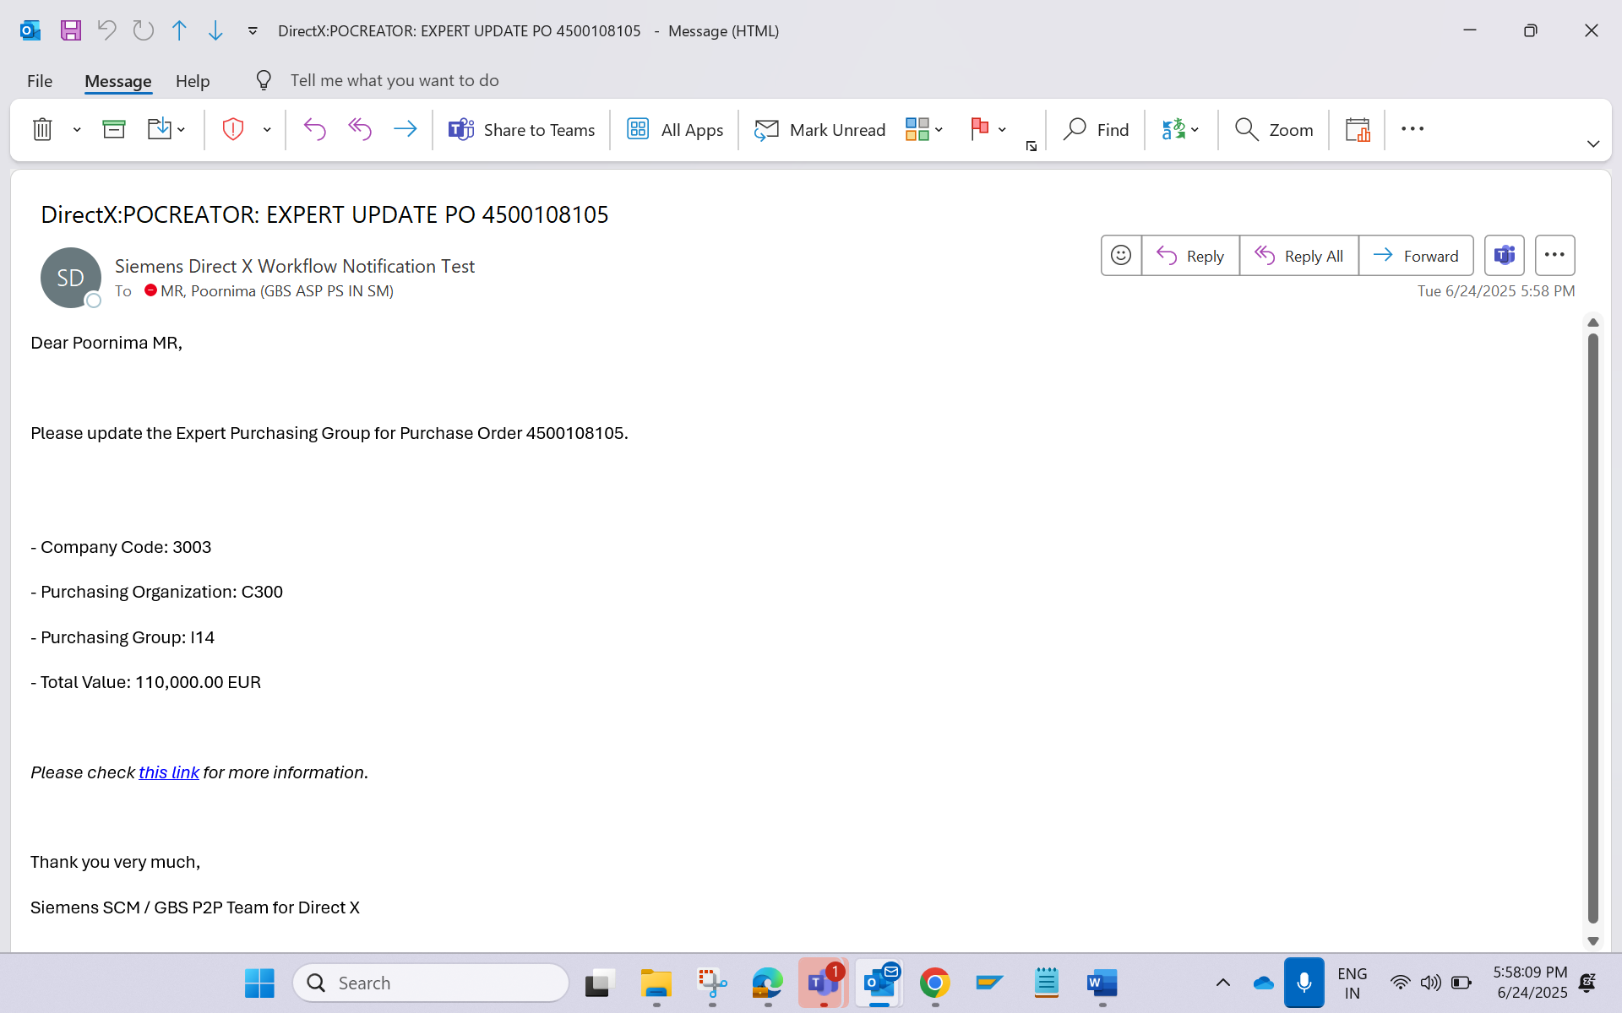

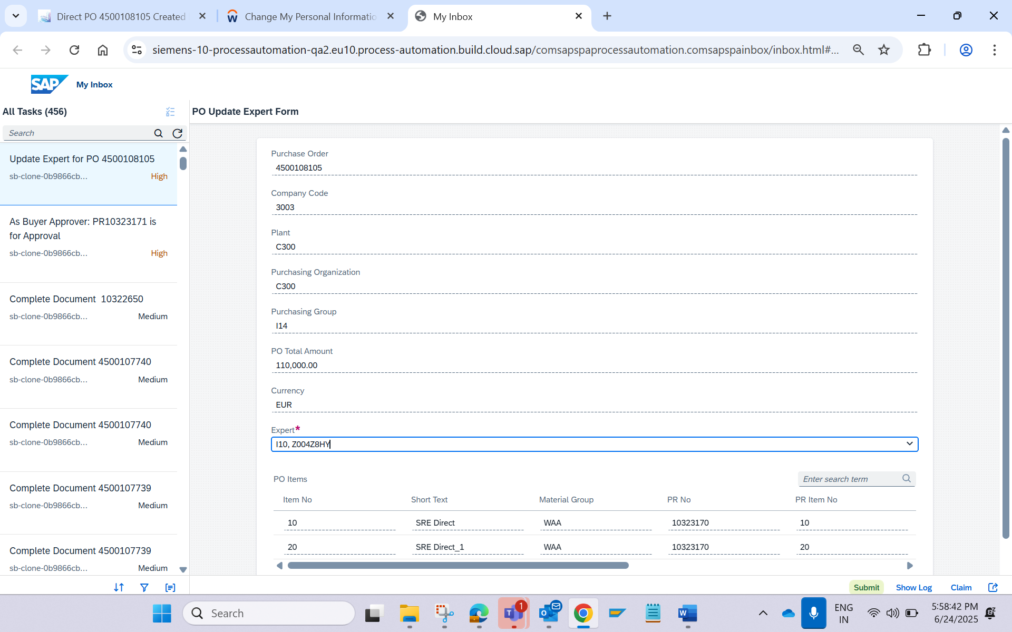

PO creator - Change the Value of 1st Line item (Any line item) to retrigger the new notification
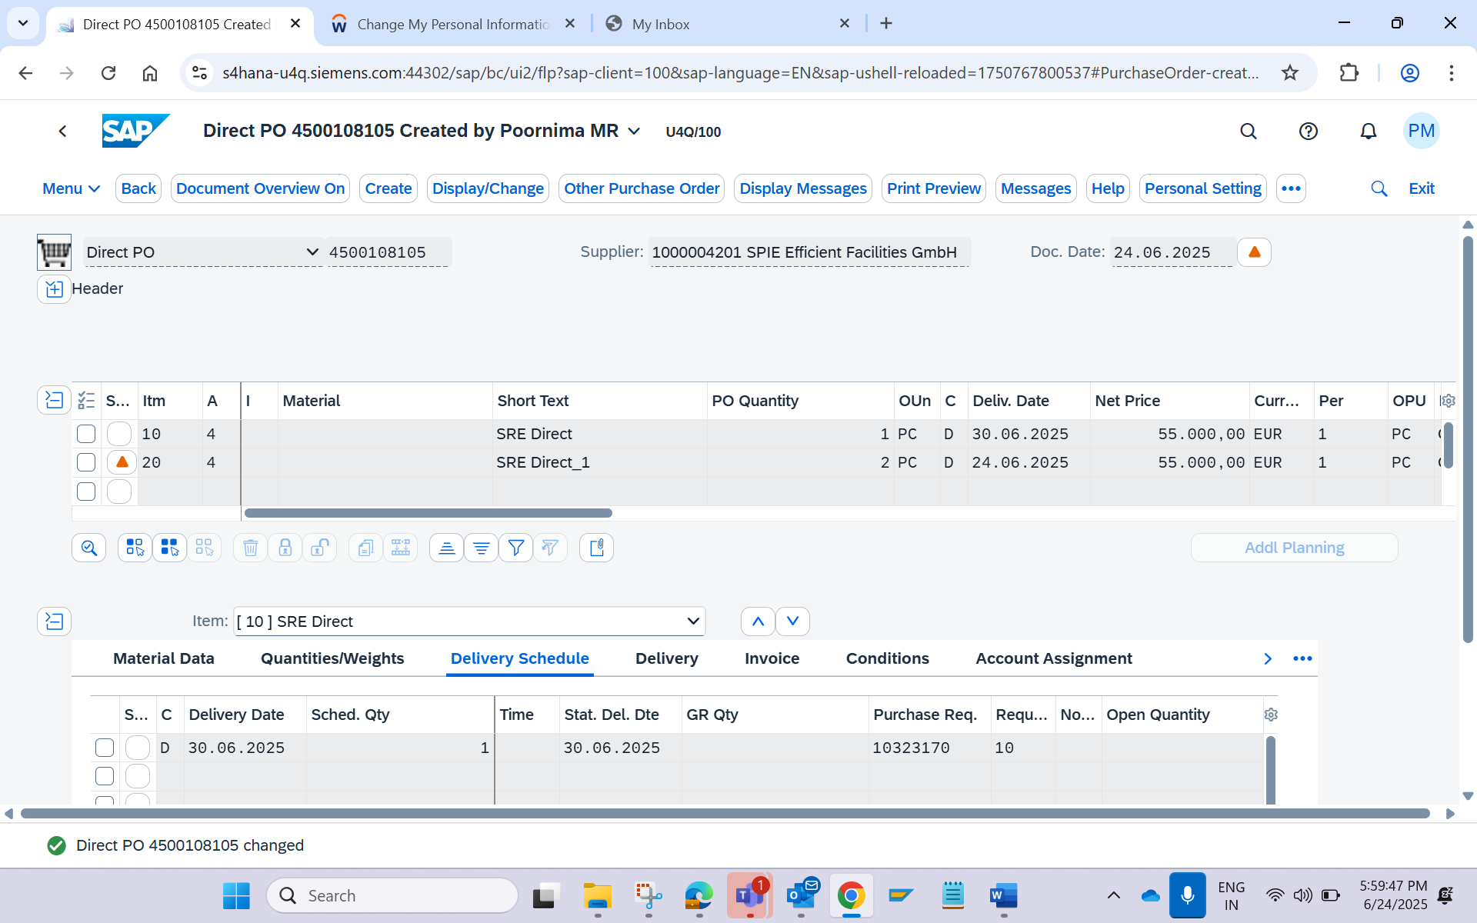
Quantity has been increased to 2PC.

New Mail with Updated value will be retriggered and BTP notification to select the Expert
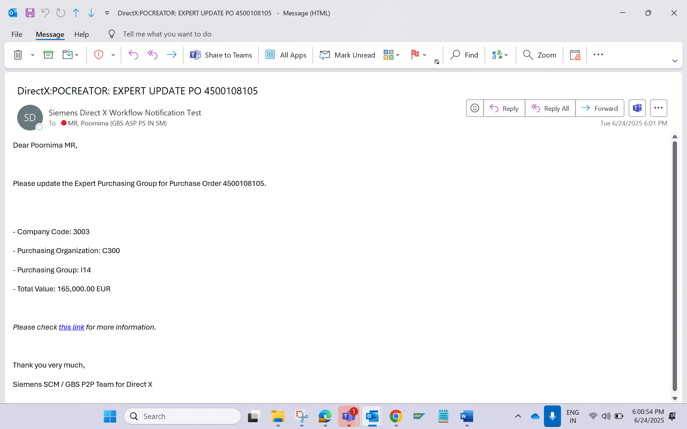

Select the Expert and Approve the PO as PO creator
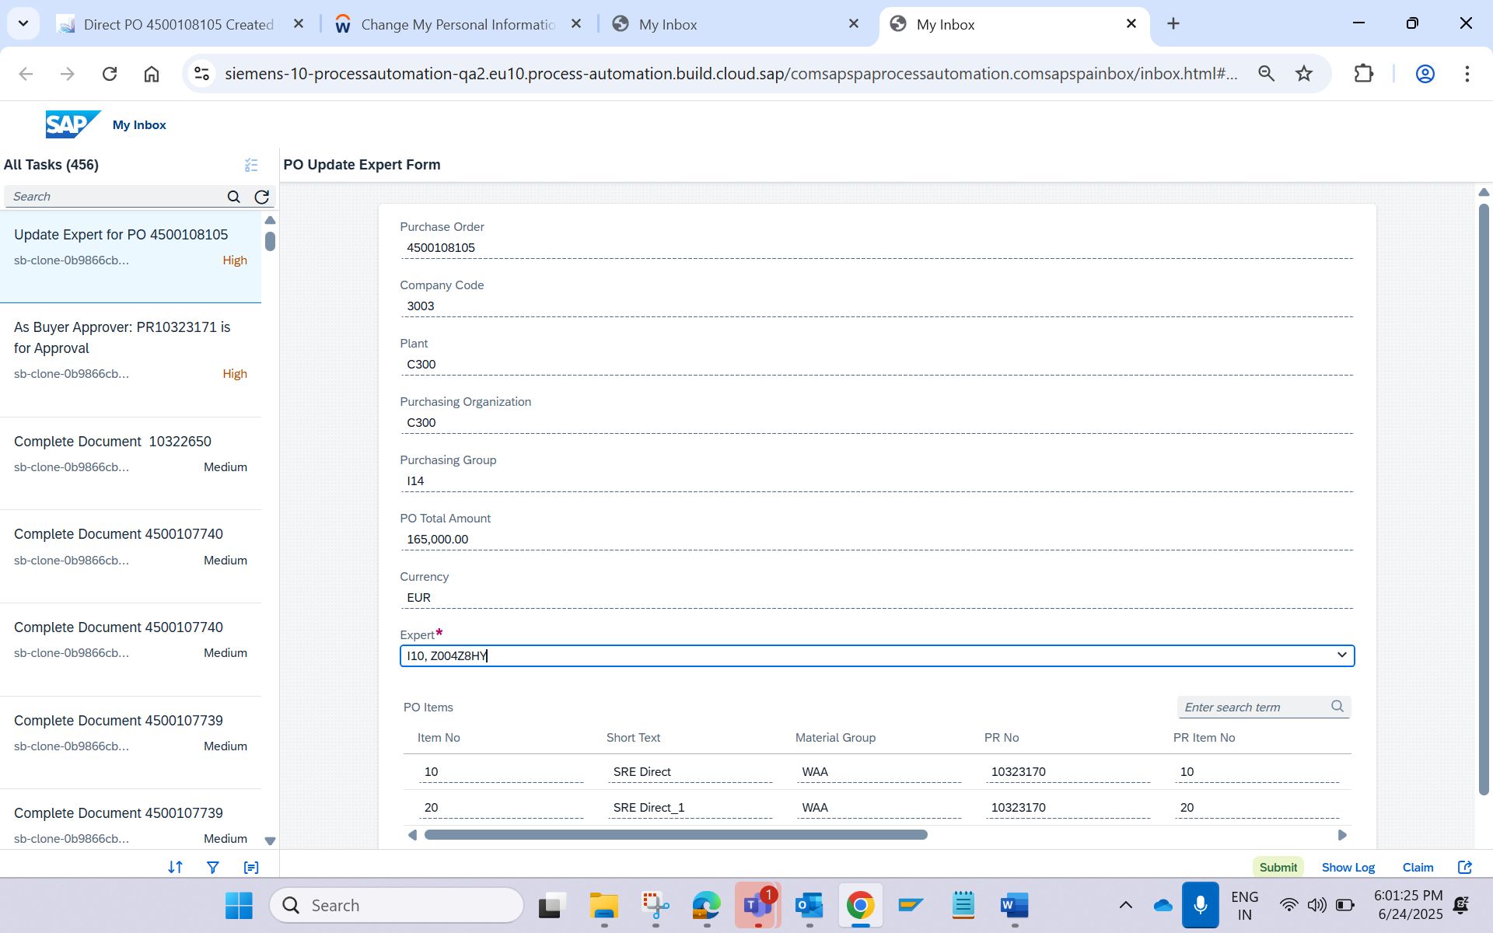

A Mail will be received to PO creator after selection of Expert
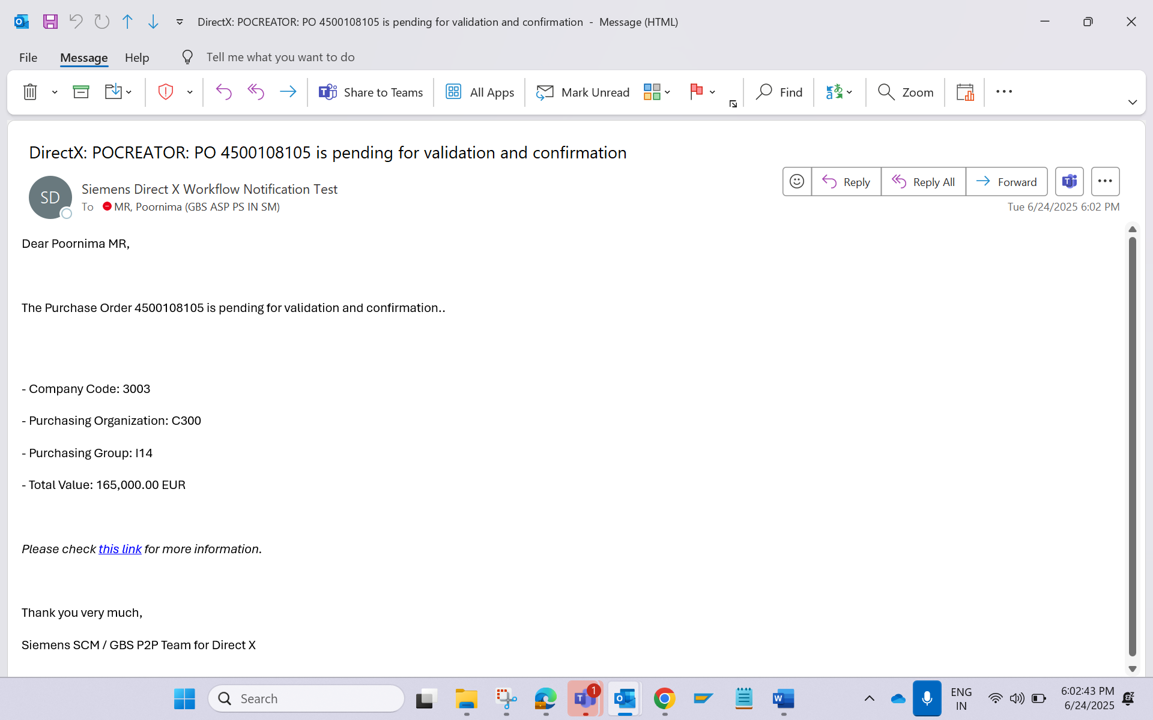

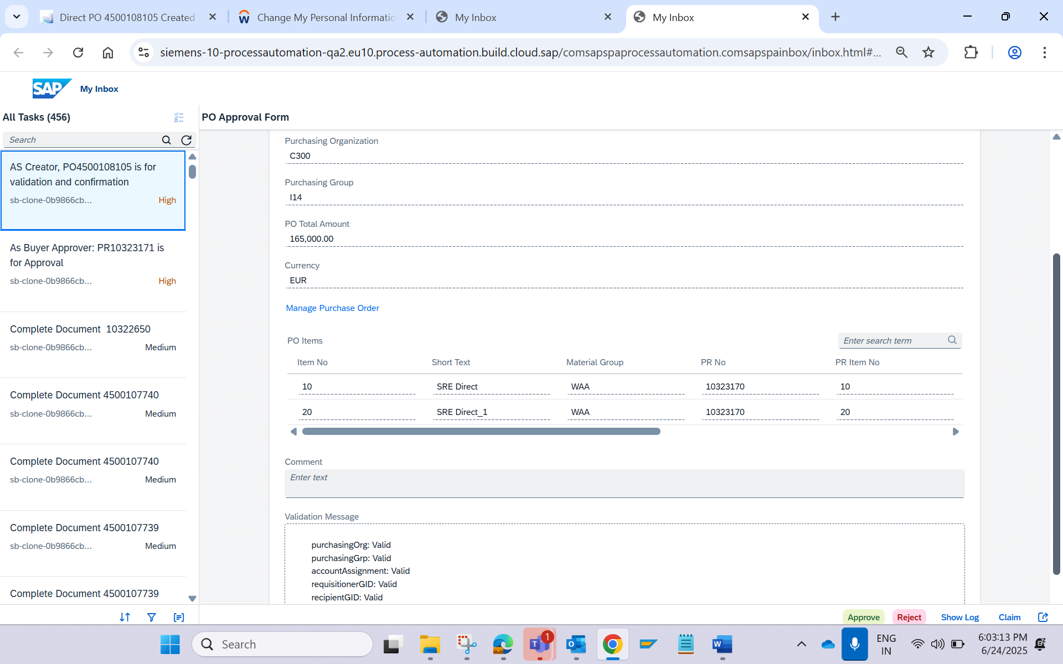

Expert Receive the Email Notification and BTP inbox Notification
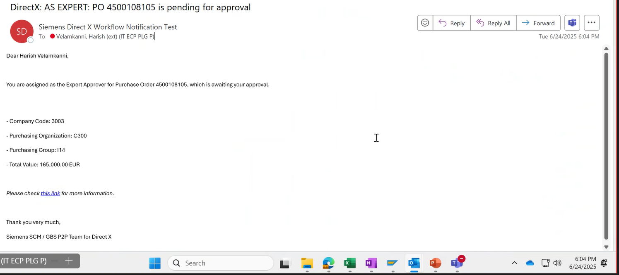

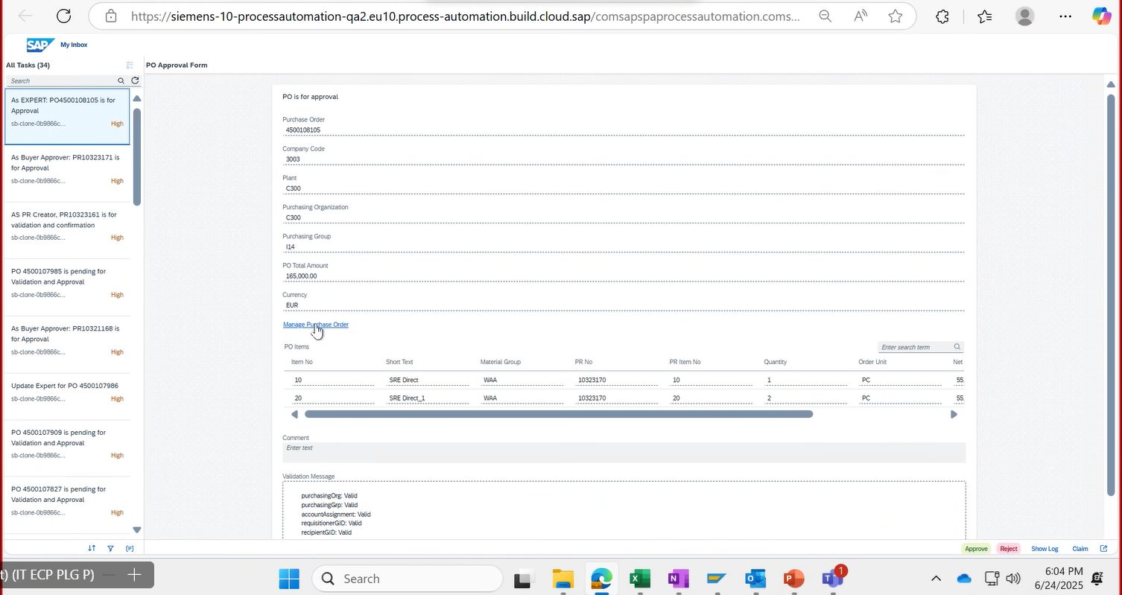

Expert Changes the value and Again the PO workflow will be retriggered
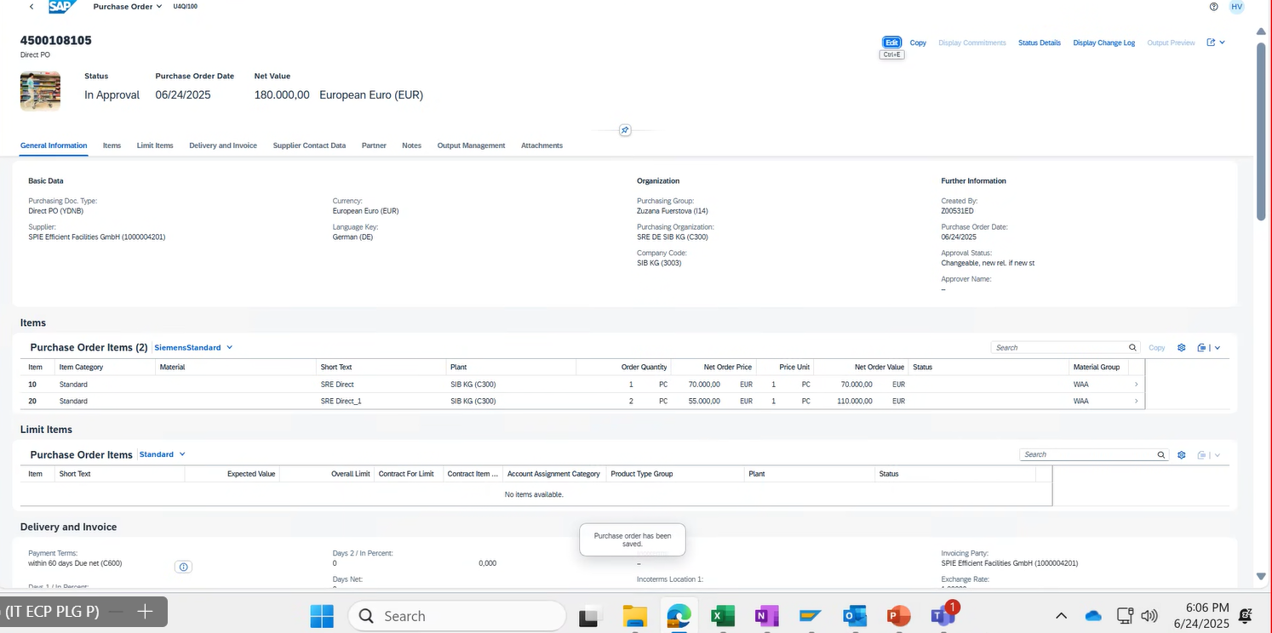

PO creator: A New Workflow will be Retriggered, select the Expert and approve the PO
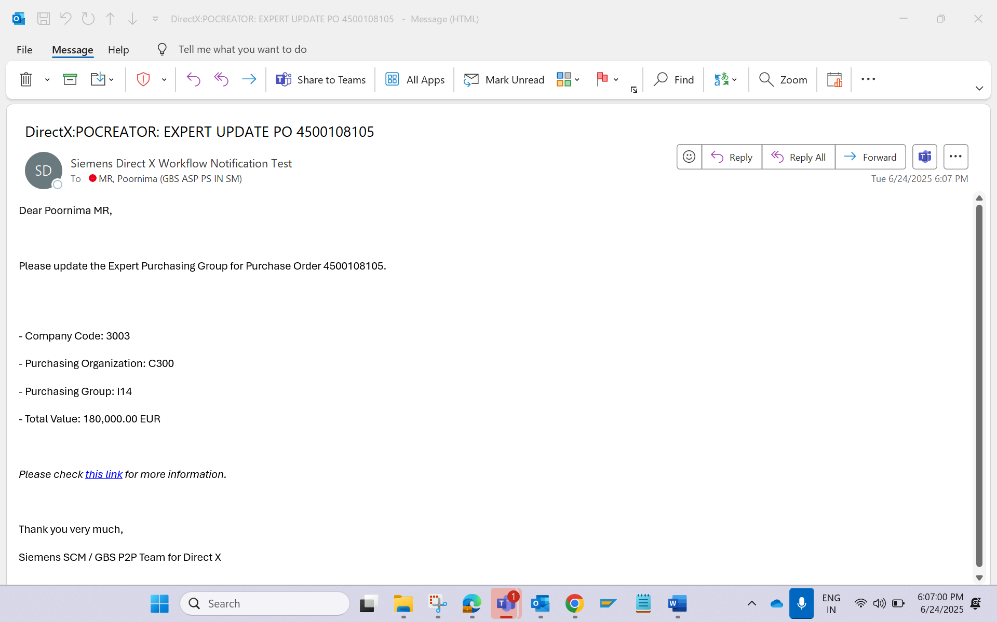

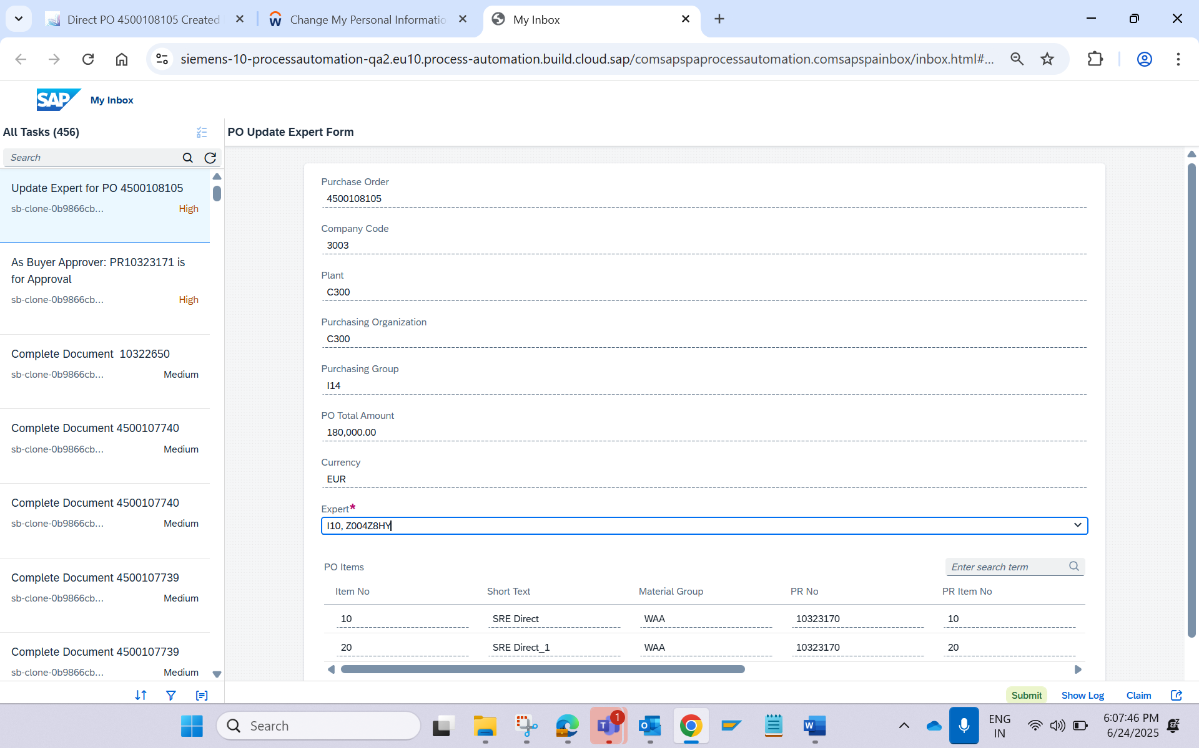

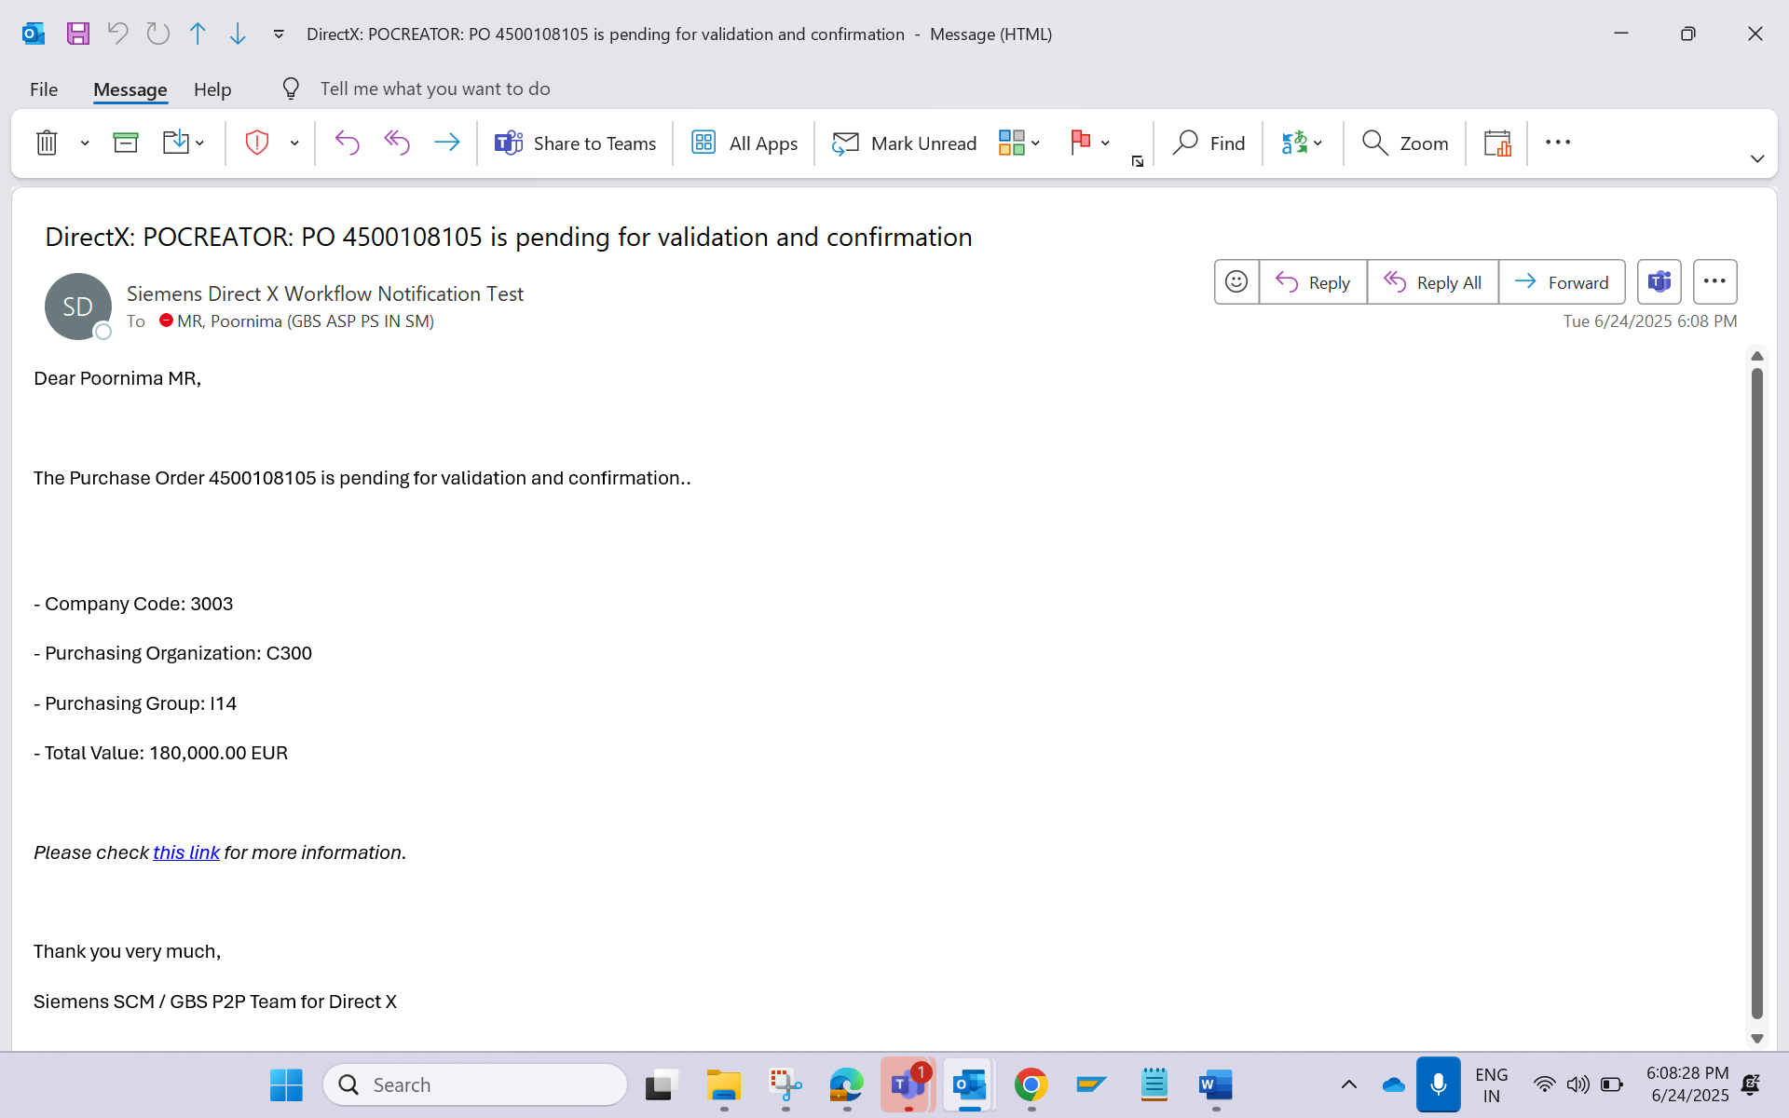

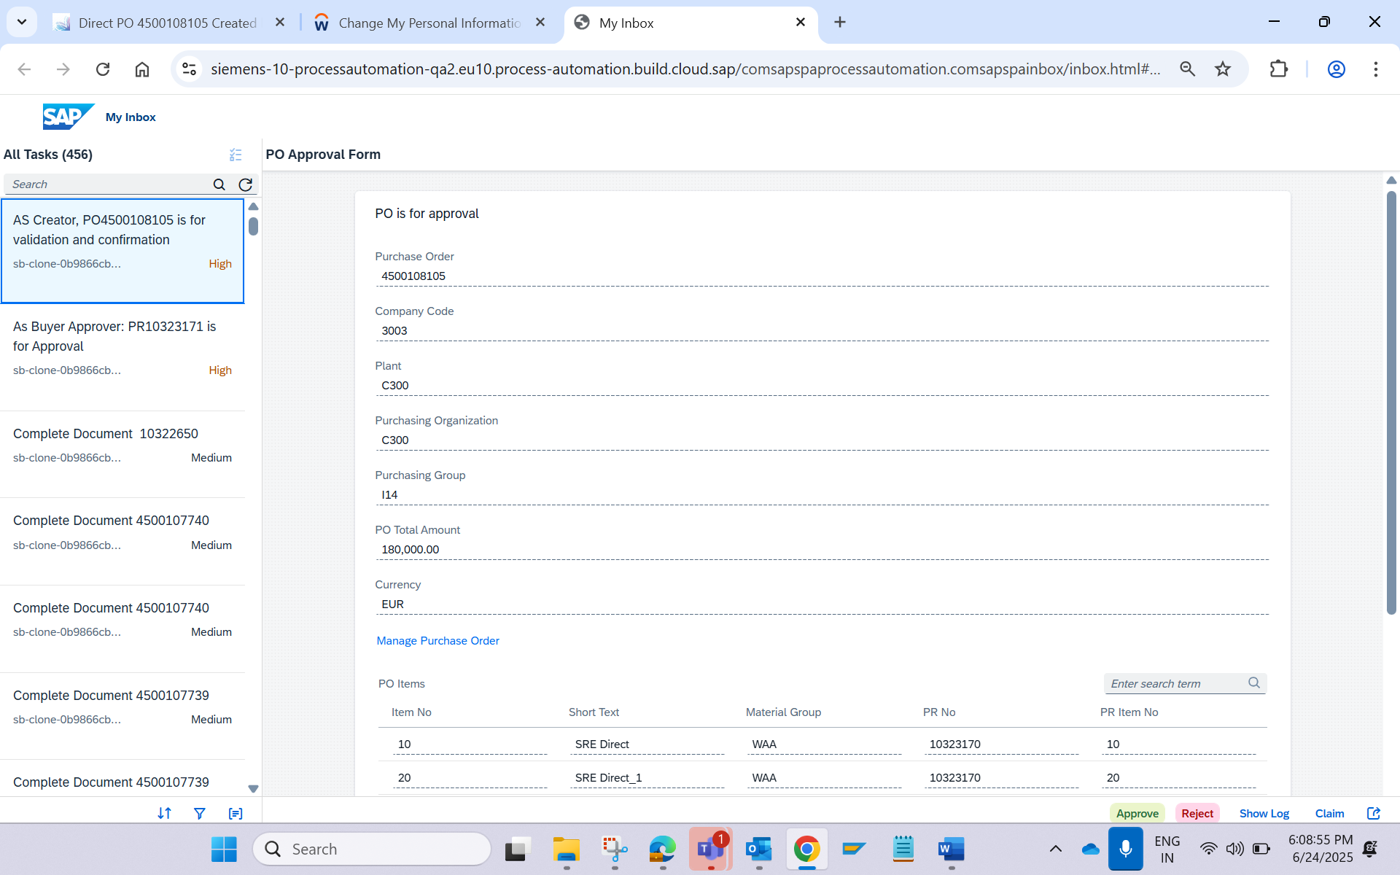

Expert receive mail and BTP notification, Expert Approves the PO
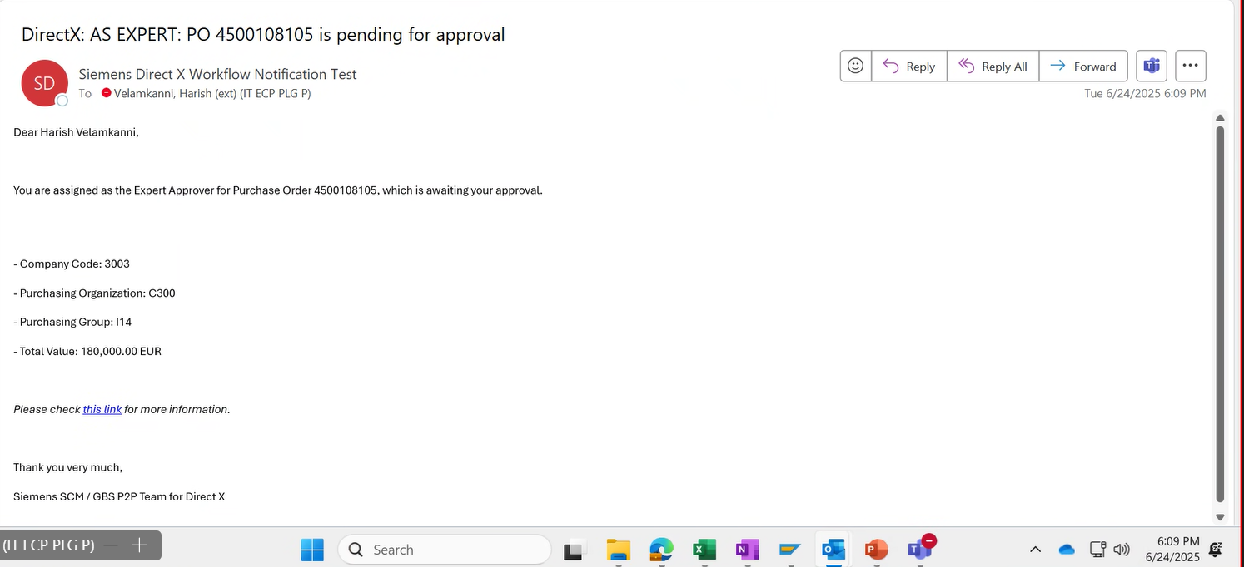

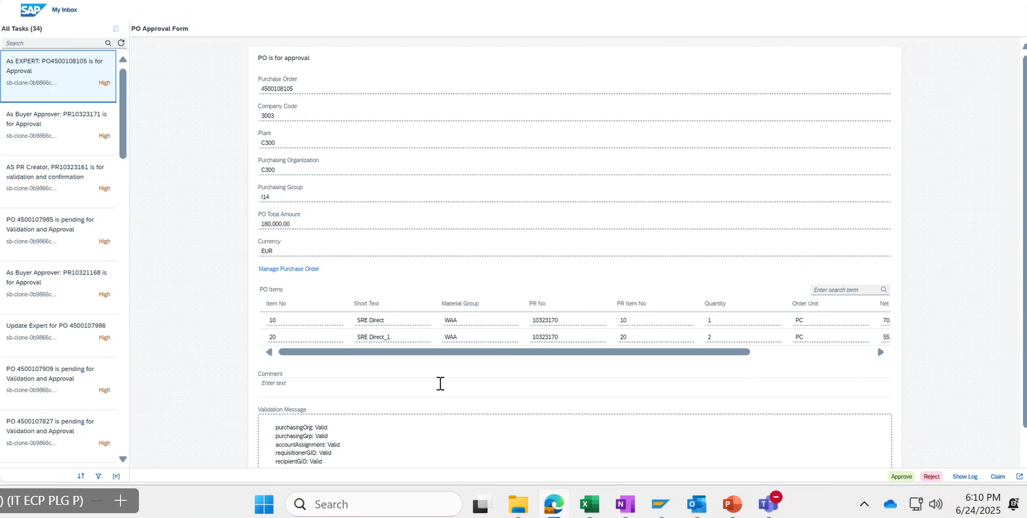

Functional Approver receive Email and BTP notification
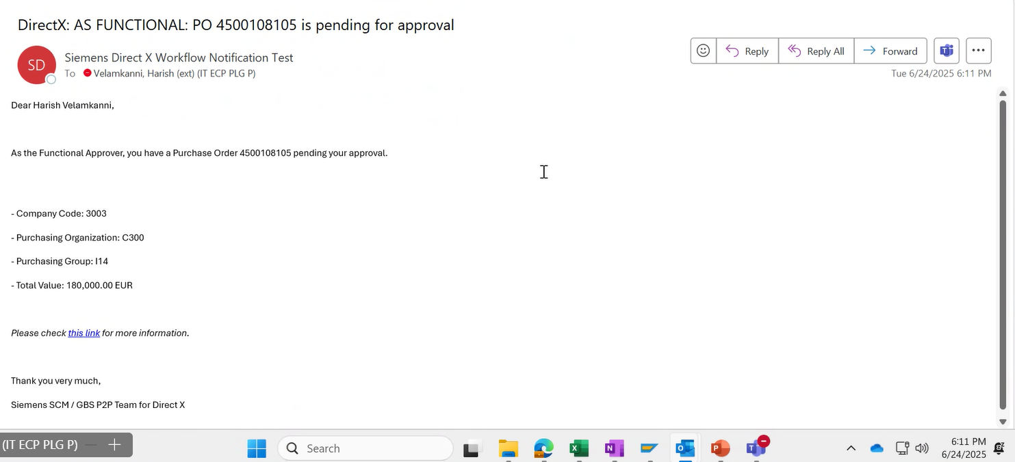

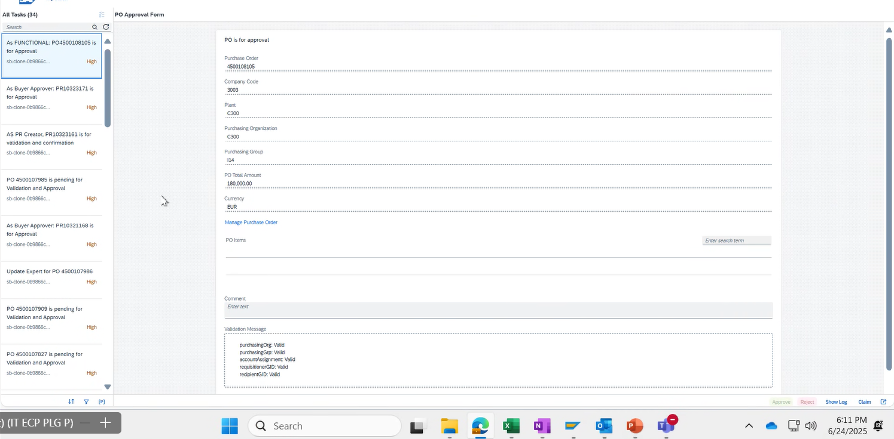

Commercial Approver receive Email and BTP Notification
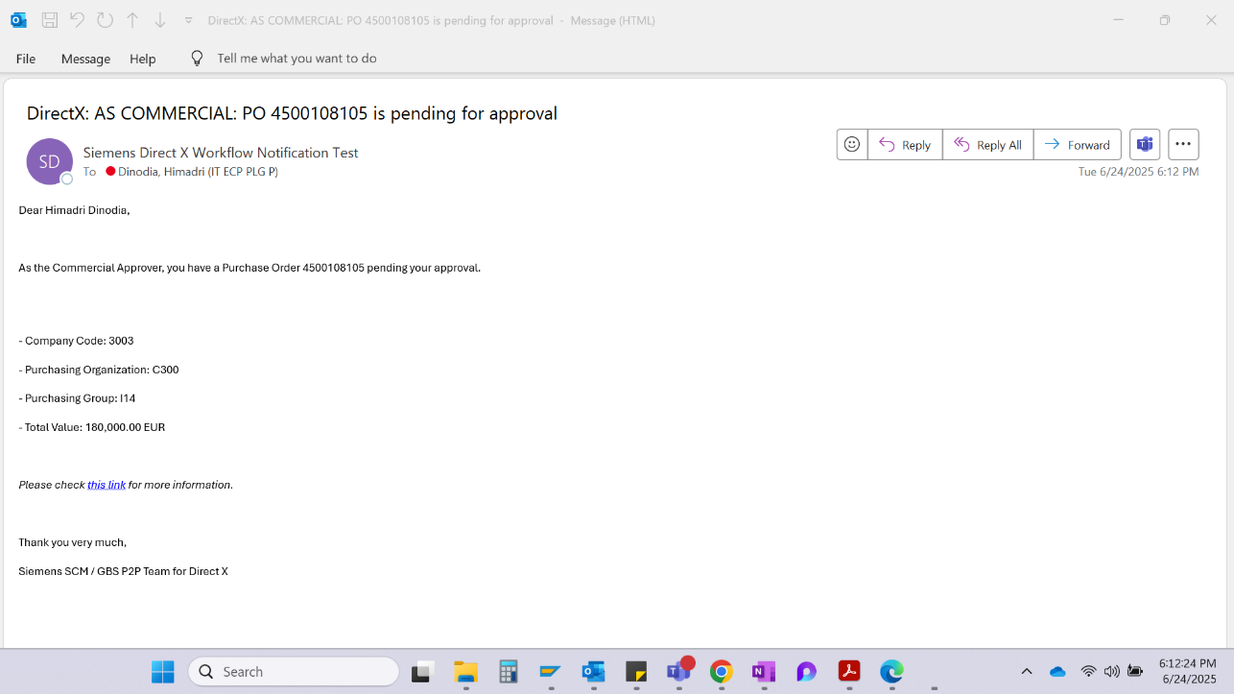

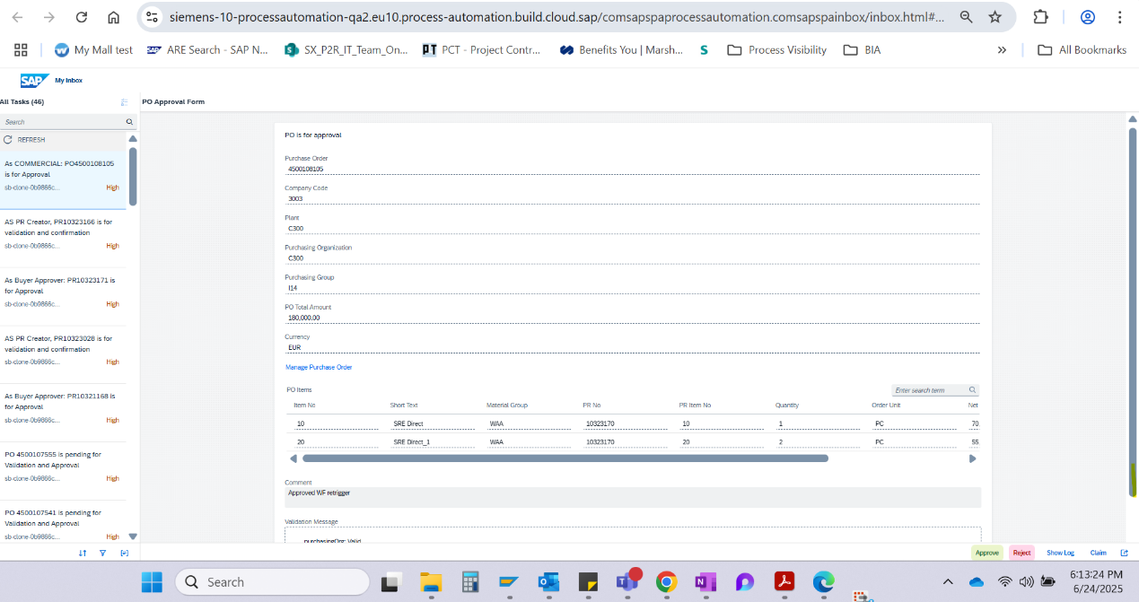

PO Has been Released
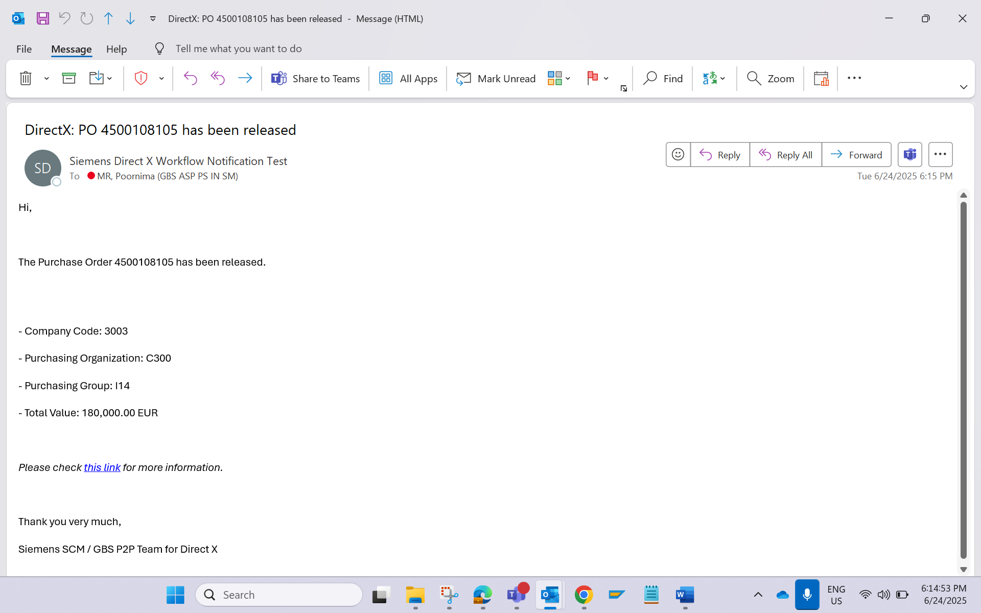

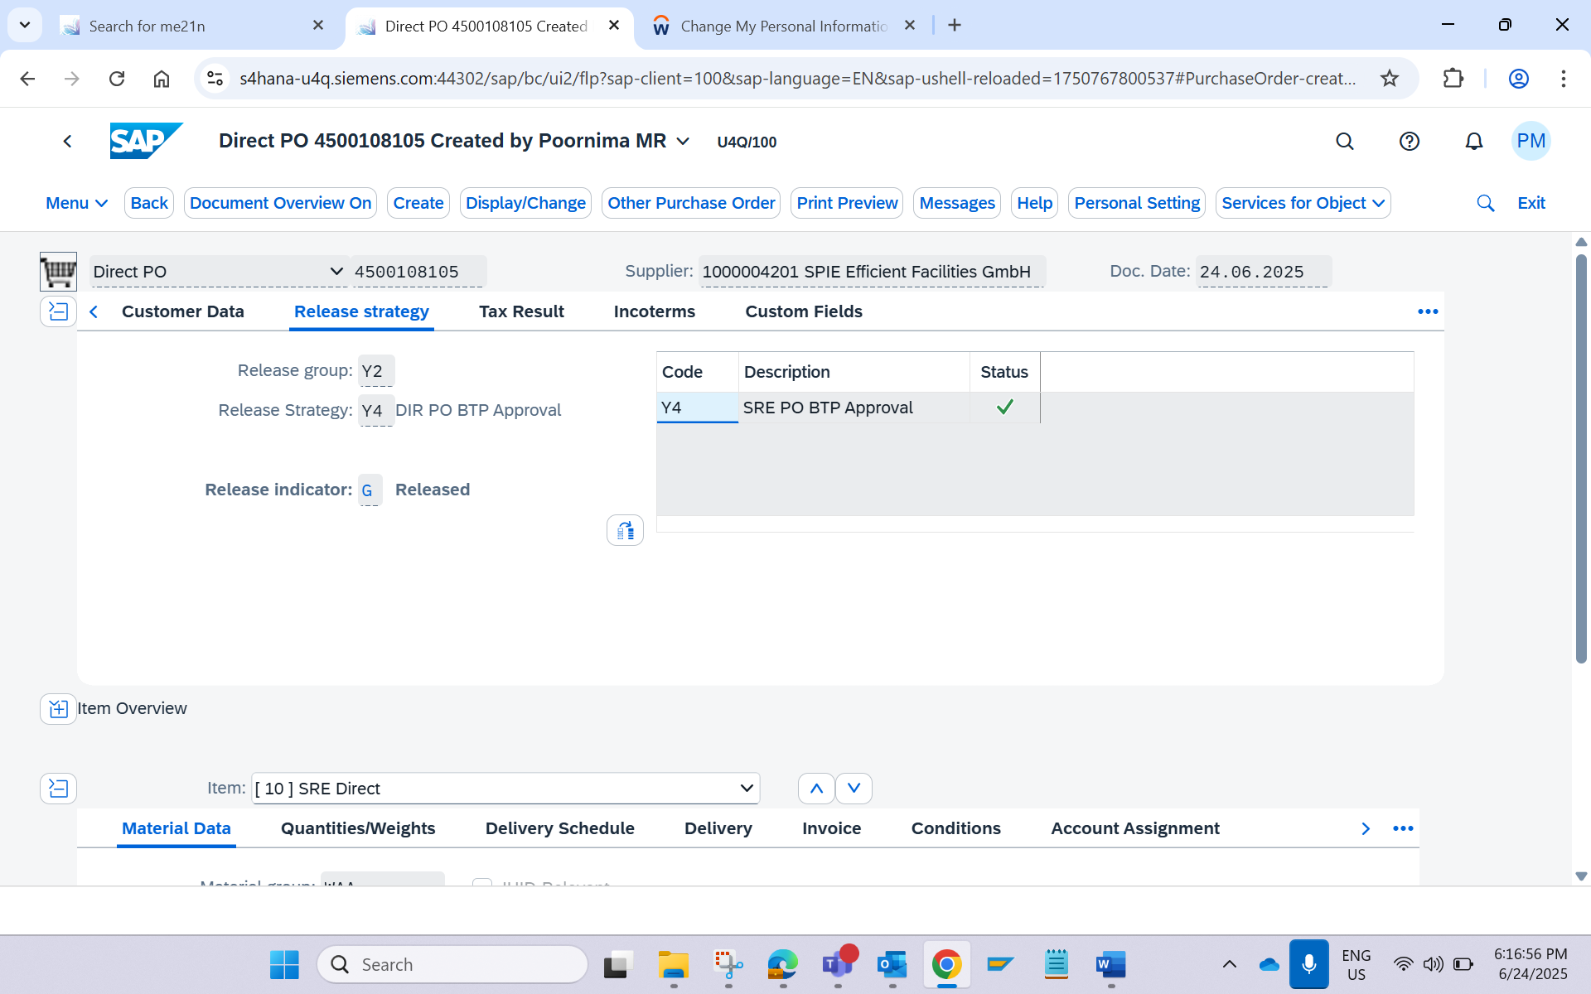

Test was successful  Please attach a screenshot of the result and of any documents output. | ☒
Test was not successful  Please attach a screenshot of the result and any error messages.  Consider a new test. Test document should be enhanced by another test case. | ☐

